PROGRAM DEFINITION
- This program is used to maintain Utility Charges

RELATED TABLES
Access
RW
R

RELATED PROGRAMS
Access

ROLES
Test

INITIAL PROCESS
Test
- Get Property List [PROPERTY_LIST]:
EXEC RSP_GS_GET_PROPERTY_LIST Login CCOMPANY_ID

Set Value : CPROPERTY_NAME
As Parameter: CPROPERTY_ID

TAB - GENERAL

USER INTERFACE
[CR14]
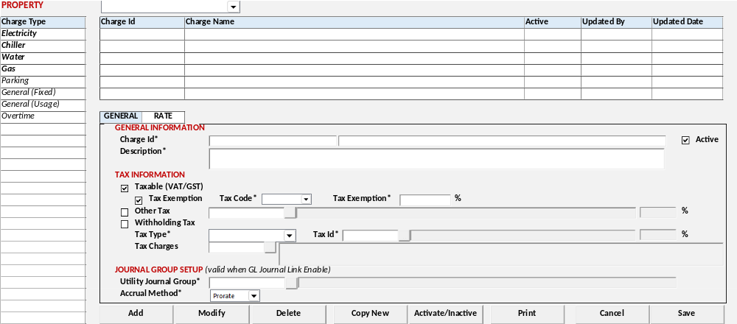
[CR11]
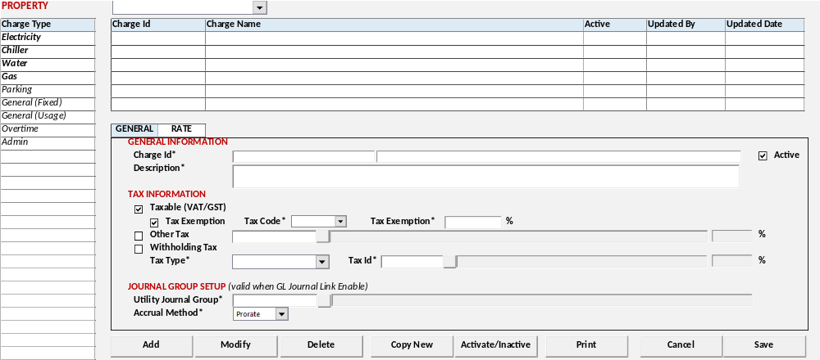

[CR05]
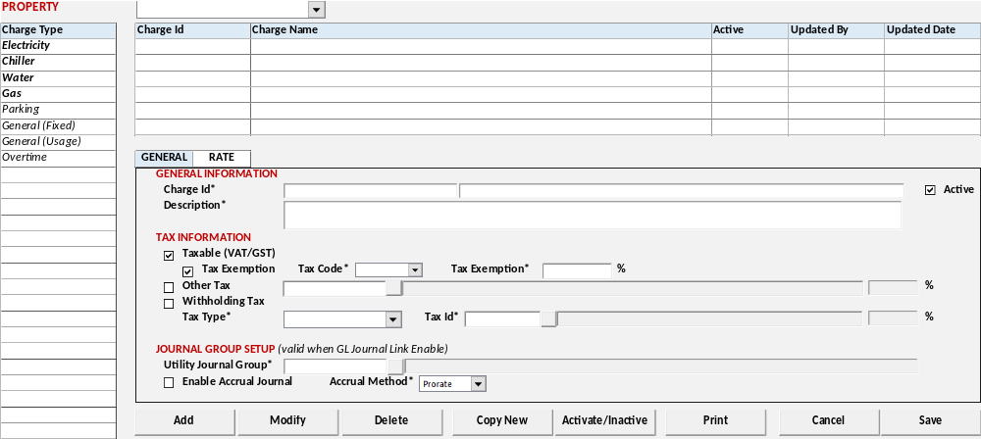
[CR04]
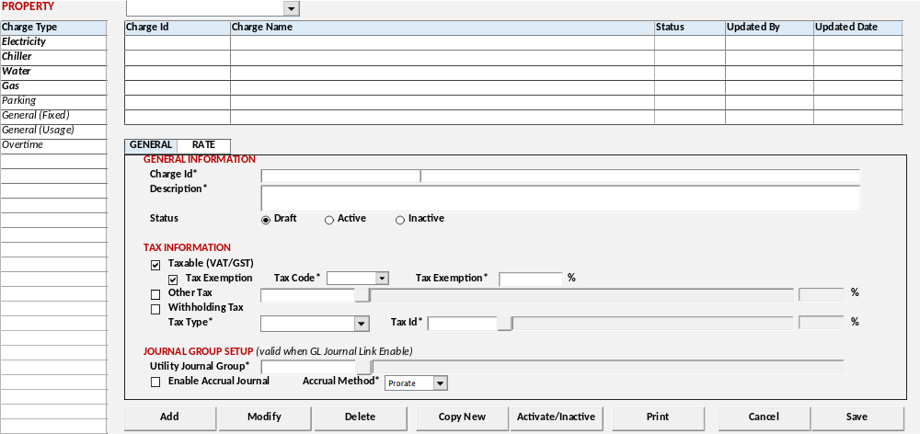

[CR02]
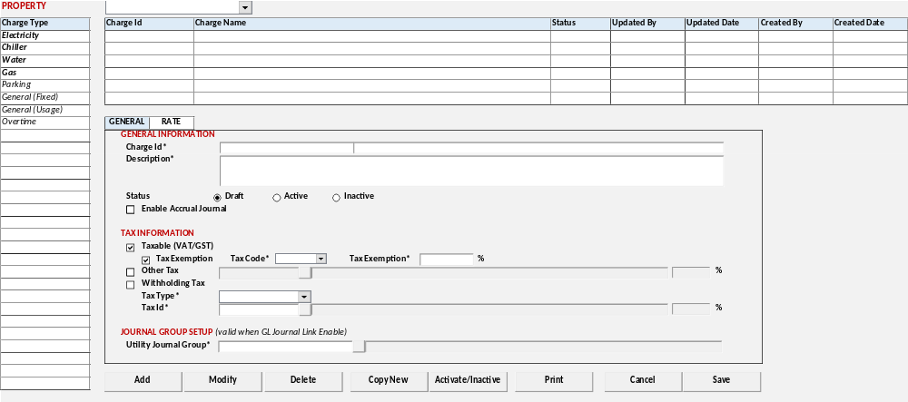
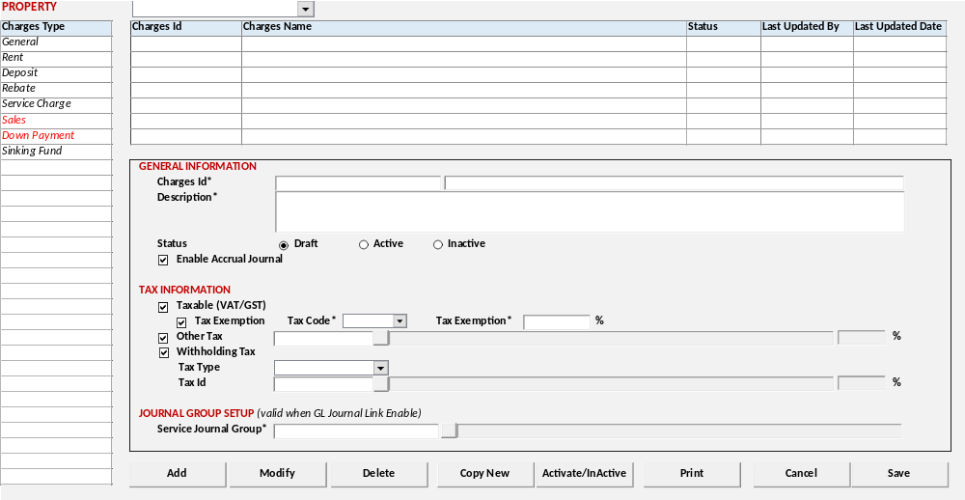

BUTTON DEFINITION
Test

DISPLAY PROCESS
Test
- Load Charges Type
  - "Charges Type"
    - Textbox
    - Field = CCHARGES_TYPE
    - Value =
SELECT CCODE, CDESCRIPTION FROM RFT_GET_GSB_CODE_INFO
('BIMASAKTI', [Login Company Id], '_BS_UTILITY_CHARGES_TYPE', '', [Login Language Id])

Load Charges Type List [CHARGES_TYPE_LIST]

EXEC RSP_PM_GET_CHARGES_UTILITY_LIST @CCOMPANY_ID, @CPROPERTY_ID, @CCHARGE_TYPE_ID, @CUSER_LOGIN_ID

- Display data [CHARGES_TYPE_LIST]:
  - "Charges Id "
    - Textbox
    - Display = CCHARGES_ID
    - VARCHAR(20)

  - "Utility Name"
    - Textbox
    - Display = CCHARGES_NAME
    - NVARCHAR(100)
[CR05]
  - "Status"
    - Textbox
    - Display = CSTATUS_DESCRIPTION
  - "Active "
    - Checkbox
    - Display = LACTIVE
[CR05]

  - [CR02] "Last Updated By"
    - Textbox
    - Display = CUPDATE_BY
    - Value = User Login Id
    - Disabled

  - [CR02]"Last Updated Date"
    - Textbox
    - Display = CUPDATE_DATE
    - Value = Today Date
    - Disabled

  - [CR02]"Created By"
    - Textbox
    - Display = CCREATE_BY
    - Value = User Login Id
    - Disabled

  - [CR02]"Created Date"
    - Textbox
    - Display = CCREATE_DATE
    - Value = Today Date
    - Disabled

Load Charges Type Detail [CHARGES_TYPE_DETAIL]

EXEC RSP_PM_GET_CHARGES_UTILITY_DETAIL @CCOMPANY_ID, @CPROPERTY_ID, @CCHARGE_TYPE_ID, @CCHARGES_ID, @CUSER_LOGIN_ID

- Display data [CHARGES_TYPE_DETAIL]:
GENERAL INFORMATION
  - "Charges Id*"
    - Textbox
    - Display = CCHARGES_ID, CCHARGES_NAME
    - VARCHAR(20), NVARCHAR(100)
    - Mandatory

  - "Description"
    - Textbox
    - Display = CDESCRIPTION
    - NVARCHAR(MAX)
[CR05]
  - "Status"
    - Radio Button
    - Display = CSTATUS
SELECT CCODE, CDESCRIPTION FROM RFT_GET_GSB_CODE_INFO
('BIMASAKTI', [Login Company Id], '_STATUS_FLAG', '', [Login Language Id])
    - Value =
      - 00 – Draft
      - 80 – Active
      - 90 – Inactive
  - "Active"
    - Checkbox
    - Display = LACTIVE
    - Value = [1] Checked / [0] Unchecked
    - Default Value = [1] Checked
    - Disabled
[CR05/]

[CR04]
  - "Enable Accrual Journal"
    - Checkbox
    - Display = LACCRUAL
    - Value = [0] Unchecked / [1] Checked
    - Default Value = [0] Unchecked

TAX INFORMATION
  - "Taxable(VAT/GST)"
    - Checkbox
    - Display = LTAXABLE
    - Value = [0] Unchecked / [1] Checked
    - Default Value = [0] Unchecked
    - IF Checked, Enabled:
      - "Tax Exemption" Flag
        - Checkbox
        - Display = LTAX_EXEMPTION
        - Value = [0] Unchecked / [1] Checked
        - Default Value = [0] Unchecked

      - "Tax Code*"
        - Combobox
        - Display = CTAX_EXEMPTION_CODE
        - Varchar(2)
        - Value =
SELECT CODE, DESCRIPTION FROM RFT_GET_GSB_CODE_INFO
('BIMASAKTI', [Login Company Id], '_TAX_CODE', '07,08', [Login Language Id])
        - Enable IF LTAX_EXEMPTION = 1

      - "Tax Exemption"
        - Textbox
        - Display = CR06] ITAX_EXEMPTION_PCT NTAX_EXEMPTION_PCT
        - Numeric Input Only, Allow Decimal Input (2angka dibelakang koma)
        - Type = Numeric(5,2)
[CR06/]
        - Enable IF LTAX_EXEMPTION = 1

  - "Other Tax"
    - Checkbox
    - Display = LACCRUAL
    - Value = [0] Unchecked / [1] Checked
    - Default Value = [0] Unchecked
    - If Checked, enable lookup:
      - "Other Tax"
        - Lookup
        - Display = COTHER_TAX_ID
        - Value =
Onclick button lookup: Run GSL00100 – Sales Tax Lookup
Get Display Value =
CTAX_ID, CTAX_NAME, NTAX_PERCENTAGE

  - "Withholding Tax"
    - Checkbox
    - Display = LWITHHOLDING_TAX
    - Value = [0] Unchecked / [1] Checked
    - Default Value = [0] Unchecked
    - If Checked, enable:
      - "Tax Type"
        - Combobox
        - Display = CWITHHOLDING_TAX_TYPE
        - Value =
SELECT CODE, DESCRIPTION FROM RFT_GET_GSB_CODE_INFO
('BIMASAKTI', [Login Company Id], '_BS_TAX_TYPE', '', [Login Language Id])

      - "Tax Id"
        - Lookup
        - Display = CWITHHOLDING_TAX_ID
        - Value =
Onclick button lookup: Run GSL00200 – Withholding Tax Lookup
Get Display Value =
CTAX_ID, CTAX_NAME, NTAX_PERCENTAGE
  - "Tax Charges" [CR14]
        - Lookup
        - Field = CTAX_CHARGES_ID
        - Value = GSL03300 – Tax Charges Lookup
Dengan parameter:
          - Company Id
          - Ref Type = 06,07 (Hardcoded)
          - Ref Code = ‘’
          - User Id
        - Get Display Value = CREF_CODE, CREF_DESCRIPTION

JOURNAL GROUP SETUP (valid when GL Journal link enable)
  - "Service Journal Group*"
    - Lookup
    - Display = CSERVICE_JRNGRP_CODE
    - Value = GSL00400 – JOURNAL GROUP LOOKUP
With Parameter:
      - [Login Company Id]
      - [Selected Property Id]
      - ‘11’

[CR04]
[CR11]
  - "Enable Accrual Journal"
    - Checkbox
    - Display = LACCRUAL
    - Value = [0] Unchecked / [1] Checked
    - Default Value = Get Value LACCRUAL from selected "Service Journal Group"

  - "Accrual Method*"
    - Combobox
    - Display = CACCRUAL_METHOD_NAME
    - Field = CACCRUAL_METHOD
    - Value =
SELECT * FROM RFT_GET_GSB_CODE_INFO ('BIMASAKTI', [Login Company Id], '_BS_ACCRUAL_METHOD', '', [Login Language Id])
    - [CR11] Enable IF LACCRUAL from selected "Service Journal Group" = true
[CR04/]
- Proses
        - "Add New" Go to ADD NEW PROCESS
        - "Edit" Go to EDIT PROCESS
        - "Delete" Go to DELETE PROCESS

ADD NEW PROCESS
Test
- Set VAR_SAVE_MODE = NEW
- Enabled fields: All Field
- Set focus to column: "Charges Id"

- Proses
        - “Save” Go to SAVE & VALIDATION PROCESS
        - “Cancel” Go to DISPLAY PROCESS

EDIT PROCESS
Test
- Set VAR_SAVE_MODE = EDIT
- Enabled fields: All Field
- Disabled fields: "Charges Id" Code
- Set focus to column: "Charges Id" Name

- Proses
        - “Save” Go to SAVE & VALIDATION PROCESS
        - “Cancel” Go to DISPLAY PROCESS

DELETE PROCESS
Test
- Set VAR_SAVE_MODE = DELETE

[CR07]
- Validasi jika sudah ada rate, maka akan menghapus rate yang sudah ada

EXEC RSP_PM_VALIDATION_UTILITY_CHARGES "Login Company Id", "Property Id", "Charges Type", "Charges Id*" Code, Login User Id

Tampilkan warning message:
"Delete this record will deleted all rate for this charge, do you want to processed? " YES / NO

IF YES, jalankan process DELETE PROCESS
IF NO, Back to Display Process
[CR07/]

- DELETE PROCESS
EXEC RSP_PM_MAINTAIN_UTILITY_CHARGES
"Login Company Id"
, "Property Id"
, "Charges Type"
, "Charges Id*" Code
, "Charges Id*" Name
, "Description"
[CR05], "Status" "Active"
, "Enable Accrual Journal"
, "Taxable(VAT/GST)" Flag
, "Tax Exemption" Flag
, "Tax Code*"
, "Tax Exemption" %
, "Other Tax" Flag
, "Other Tax"
, "Withholding Tax"
, "Tax Type"
, "Tax Id"
, "Service Journal Group"
[CR04] , "Accrual Method"
, "DELETE"
, Login User Id

SAVE & VALIDATION PROCESS
Test
[CR04]
- Validation
If Action = Edit
IF "Enable Accrual Journal" changes value from 1 to 0, show message
"Are you sure to disabled Accrual Journal? " YES / NO
IF Yes Go To Save Utility Charges
IF No Back to Display Process
[CR04]

[CR05]
- IF Action "Add", and "Active" Flag = True, jalankan
Jalankan GFF00900 – Activity Approval dengan parameter:
CACTION_CODE = 'PMM01001'

IF Success, jalankan Save Utility Charges Process, IF Failed, stay on Add/Edit Process

- Save Utility Charges

EXEC RSP_PM_MAINTAIN_UTILITY_CHARGES
"Login Company Id"
, "Property Id"
, "Charges Type"
, "Charges Id*" Code
, "Charges Id*" Name
, "Description"
[CR05], "Status" "Active"
, "Enable Accrual Journal"
, "Taxable(VAT/GST)" Flag
, "Tax Exemption" Flag
, "Tax Code*"
, "Tax Exemption" %
, "Other Tax" Flag
, "Other Tax"
, "Withholding Tax"
, "Tax Type"
, "Tax Id"
, "Service Journal Group"
[CR04] , "Accrual Method"
, CACTION [ADD / EDIT]
, Login User Id
, [CR14], "Tax Charges"

[CR01]
- Save Utility Rate
  - Electricity and Chiller
IF "Charges Type" = 01 Electricity / 02 Chiller
DECLARE @CRATE_EC_LIST AS RDT_COMMON_OBJECT

INSERT INTO @CRATE_EC_LIST (
COBJECT_ID, COBJECT_DESC, CATTRIBUTE01, CATTRIBUTE02, CATTRIBUTE03, CATTRIBUTE04, CATTRIBUTE05, CATTRIBUTE06, CATTRIBUTE07, CATTRIBUTE08)

VALUES
[Login Company Id]
,[Selected Property Id]
, "Charges Type"
, "Charges Id*" Code
, "Usage (KWH)"
, "Description"
, "BUYING PRICE" - "LWBP Charges"
, "BUYING PRICE" - "WBP Charges"
, "SELLING PRICE" - "LWBP Charges"
, "SELLING PRICE" - "WBP Charges"

EXEC RSP_PM_MAINTAIN_RATE_EC
"Login Company Id"
, "Property Id"
, "Charges Type"
, "Charges Id*" Code
, "Usage Rate Mode"
, "Rate Type"
, "Standing Charge" - Buying Price
, "Standing Charge" - Selling Price
, "LWBP Charge" - Buying Price
, "LWBP Charge" - Selling Price
, "WBP Charge" - Buying Price
, "WBP Charge" - Selling Price
, "Transformator Fee" - Buying Price
, "Transformator Fee" - Selling Price
, "Usage Minimum Charge" Flag
, "Usage Minimum Charge"
, "KWH Used Maximum"
, "KWA Used Rate" - Buying Price
, "KWA Used Rate" - Selling Price
, "Retribution %"
, "Excluded from VAT" Flag
, "Administration Fee (per month)"
, "Administration Fee percentage"
, "Administration Fee Fix Amount"
, "Taxable"
, "KWA Used Maximum"
, "Other Disincentive Factor"
, "KVA Range" - Buying Price
, "KVA Range" – Selling Price
, CACTION [ADD / EDIT]
, Login User Id
, @CRATE_EC_LIST

  - Water and Gas
IF "Charges Type" = 03 Water / 04 Gas
DECLARE @CRATE_WG_LIST AS RDT_COMMON_OBJECT

INSERT INTO @CRATE_WG_LIST (
COBJECT_ID, COBJECT_DESC, CATTRIBUTE01, CATTRIBUTE02, CATTRIBUTE03, CATTRIBUTE04, CATTRIBUTE05, CATTRIBUTE06)

VALUES
[Login Company Id]
,[Selected Property Id]
, "Charges Type"
, "Charges Id*" Code
, "Usage (m3)"
, "Description"
, "BUYING PRICE"
, "SELLING PRICE"

EXEC RSP_PM_MAINTAIN_RATE_WG
"Login Company Id"
, "Property Id"
, "Charges Type"
, "Charges Id*" Code
, "Currency Code"
, "Pipe Size"
, "Standing Charge" - Buying Price
, "Standing Charge" - Selling Price
, "Usage Rate Mode"
, "Usage Charge Rate*"
, "Usage Minimum Charge (per month)" Flag
, "Usage Minimum Charge (per month)"
, "Maintenance Fee (per month)"
, "Administration Fee (per month)"
, "Administration Fee percentage"
, "Administration Fee Fix Amount"
, "Taxable"
, "Administration Fee For" - "Standing Charges"
, "Administration Fee For" - "Usage"
, "Administration Fee For" - "Maintenance"
, CACTION [ADD / EDIT]
, Login User Id
, @CRATE_WG_LIST

  - Parking and General Fixed
IF "Charges Type" = 05 Parking / 06 General (Fixed)
EXEC RSP_PM_MAINTAIN_RATE_PG
"Login Company Id"
, "Property Id"
, "Charges Type"
, "Charges Id*" Code
, "Standing Charge" - Buying Price
, "Standing Charge" - Selling Price
, "Usage Charge Rate*" - Buying Price
, "Usage Charge Rate*" - Selling Price
, "Maintenance Fee (per month)"
, "Administration Fee (per month)"
, "Administration Fee percentage"
, "Administration Fee Fix Amount"
, "Taxable"
, "Administration Fee For" - "Standing Charges"
, "Administration Fee For" - "Usage"
, "Administration Fee For" - "Maintenance"
, CACTION [ADD / EDIT]
, Login User Id

  - General Usage
IF "Charges Type" = 07 General (Usage)
EXEC RSP_PM_MAINTAIN_RATE_GU
"Login Company Id"
, "Property Id"
, "Charges Type"
, "Charges Id*" Code
, "Standing Charge" - Buying Price
, "Standing Charge" - Selling Price
, "Usage Charge Rate*" - Buying Price
, "Usage Charge Rate*" - Selling Price
, "Maintenance Fee (per month)"
, "Administration Fee (per month)"
, "Administration Fee percentage"
, "Administration Fee Fix Amount"
, "Taxable"
, "Administration Fee For" - "Standing Charges"
, "Administration Fee For" - "Usage"
, "Administration Fee For" - "Maintenance"
, CACTION [ADD / EDIT]
, Login User Id

  - Overtime
IF "Charges Type" = 08 Overtime
DECLARE @CRATE_OT_LIST AS RDT_COMMON_OBJECT

INSERT INTO @CRATE_OT_LIST (
COBJECT_ID, COBJECT_DESC, CATTRIBUTE01, CATTRIBUTE02, CATTRIBUTE03, CATTRIBUTE04, CATTRIBUTE05, CATTRIBUTE06, CATTRIBUTE07, CATTRIBUTE08)

VALUES
[Login Company Id]
,[Selected Property Id]
, "Charges Type"
, "Charges Id*" Code
, Day Type [WD] Weekday / [WK] Weekend
, "Level"
, "Description"
, "From"
, "To"
, "Rate per Hour"

EXEC RSP_PM_MAINTAIN_RATE_OT
"Login Company Id"
, "Property Id"
, "Charges Type"
, "Charges Id*" Code
, "Currency Code"
, "Administration Fee (per month)"
, "Administration Fee percentage"
, "Administration Fee Fix Amount"
, "Unit Area Validation (sqm)" From
, "Unit Area Validation (sqm)" To
, CACTION [ADD / EDIT]
, Login User Id
, @CRATE_OT_LIST

- Go to DISPLAY PROCESS

CANCEL PROCESS
Test
- Tutup program dan kembali ke Utility Charges List

COPY NEW PROCESS

USER INTERFACE
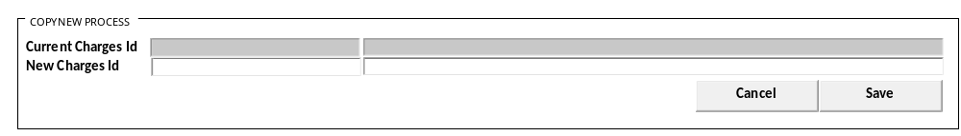

COPY NEW PROCESS
Test
  - "Current Charges Id"
    - Textbox
    - Display = CCHARGES_ID - CCHARGES_NAME
    - VARCHAR(20) NVARCHAR(100)
    - Disabled

  - "New Charges Id"
    - Textbox
    - Display = CCHARGES_ID - CCHARGES_NAME
    - VARCHAR(20) NVARCHAR(100)
    - Mandatory

On click button SAVE:
Run RSP_PM_COPY_NEW_UTILITY_CHARGES
CCOMPANY_ID
, @CPROPERTY_ID
, @CCURRENT_CHARGES_TYPE
, @CCURRENT_CHARGE_ID
, @CNEW_CHARGES_ID
, @CNEW_CHARGES_NAME
, @CUSER_LOGIN_ID

Cancel Process
Tutup program dan kembali ke Utility Charges List

ACTIVE / INACTIVE PROCESS
Test
- Validation:
- Jalankan RSP_ACTIVITY_VALIDITY {Login Company ID}, 'PMM01001'
          - If no Error maka jalankan :
            - Baca result,
            - Munculkan Pop Up dengan
              - Label Reason = {Text Box Double byte max 100}
              - Button = OK / Cancel
              - Tampung Nilai di @DETAIL_ACTION
            - If Result count = 1 and value = All, maka jalankan update
            - If Result Value <> 1 dan value <> = All maka buka GFF00900
              - @PROPERTY_NO ={Login Property Id}
              - @ACTION_CODE = 'PMM01001'
              - @DATE = @ActiveDate
              - @REQUEST_BY = {Login User Id}
              - @DETAIL_ACTION = CCOMPANY_ID + ‘|’ + hasil detail action
              - @USER_LIST = Result SP

          - Setelah melalui process applikasi tersebut, Bila Sukses jalankan :
[RSP_CREATE_ACTIVITY_APPROVAL_LOG]
@P_CCOMPANY_ID = {Login Company Id}
@P_CAPPROVAL_CODE = 'PMM01001'
@P_CREFERENCE_NO = CCOMPANY_ID
@P_CREFERENCE_INFO = CCOMPANY_ID + ‘|’ + hasil detail action
@P_DAPPROVAL_DATE = @ActiveDate
@P_CAPPROVAL_USER_ID = {Return User Id}
@P_CACTIVITY_USER_ID = {Login user Id}
@P_CREASON_CODE = ''
@P_CAPPROVAL_NOTE = @ACTION_DETAIL

- Jalankan GFF00900 – Activity Approval dengan parameter:
CACTION_CODE = 'PMM01001'

- Jika success, jalankan process ACTIVE / INACTIVE PROCESS
- ACTIVE / INACTIVE PROCESS
EXEC RSP_PM_ACTIVE_INACTIVE_UTILITY_CHARGES
Login Company Id
, Selected Property Id
, "Charges Type"
, "Charges Id"
, Status [80] Active / [90] Inactive
, Login User Id

PRINT PROCESS

USER INTERFACE
[CR05]
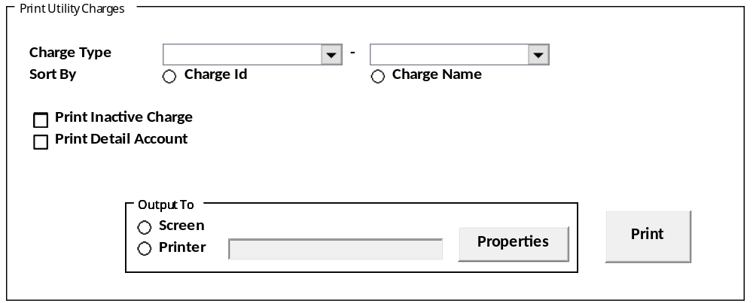
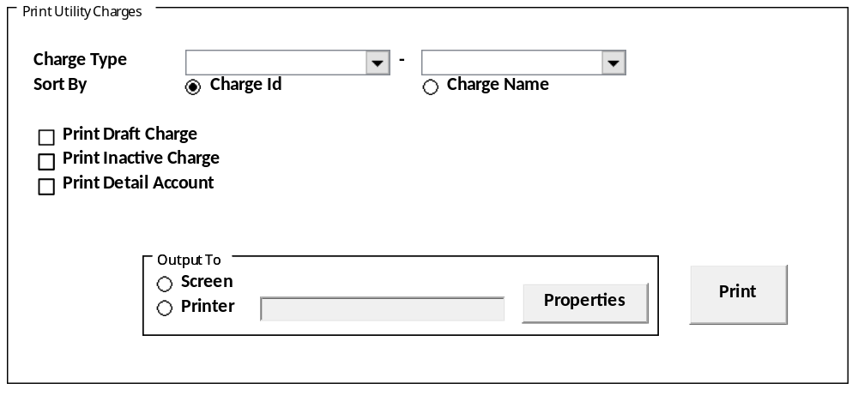

DISPLAY PROCESS
Test
  - "Charges Type" From
    - Textbox
    - Field = CCHARGES_TYPE_FROM
    - Value =
SELECT CCODE, CDESCRIPTION FROM RFT_GET_GSB_CODE_INFO
('BIMASAKTI', [Login Company Id], '_BS_UTILITY_CHARGES_TYPE', '', [Login Language Id])

  - "Charges Type" To
    - Textbox
    - Field = CCHARGES_TYPE_TO
    - Value =
SELECT CCODE, CDESCRIPTION FROM RFT_GET_GSB_CODE_INFO
('BIMASAKTI', [Login Company Id], '_BS_UTILITY_CHARGES_TYPE', '', [Login Language Id])
    - Validation: CCHARGES_TYPE_TO cannot be bigger than CCHARGES_TYPE_FROM

  - "Short By"
    - Radio Button
    - Field = CSHORT_BY
    - Value =
      - [01] Charges Id
      - [02] Charges Name
[CR05]
  - "Print Draft Charges"
    - Checkbox
    - Field = LPRINT_DRAFT
    - Value = [0] Unchecked / [1] Checked

  - "Print Inactive Charges"
    - Checkbox
    - Field = LPRINT_INACTIVE
    - Value = [0] Unchecked / [1] Checked

  - "Print Detail Account"
    - Checkbox
    - Field = LPRINT_DETAIL_ACC
    - Value = [0] Unchecked / [1] Checked

  - "Output To"
    - Radio Button
    - Field: [PARAM_OUTPUT]
      - 1 = Screen (Default)
      - 2 = Printer
    - Output’s Button
      - Properties
        - Membuka property printer
      - OK
        - Validasi:
          - IF "Charges Type" kosong tampilkan pesan
“Please select Charges Type”
          - Menjalankan proses “Print” dengan parameter:
            - [Login User].[CCOMPANY_ID]
            - Selected Property Id
            - CCHARGES_TYPE_FROM
            - CCHARGES_TYPE_TO
            - CSHORT_BY
            - [CR05] LPRINT_DRAFT
            - LPRINT_INACTIVE
            - LPRINT_DETAIL_ACC

        - Catatan: Gunakan class yang didalam framework untuk fungsi ini

- Jalankan SP untuk process Print:
RSP_PM_PRINT_UTILITY_CHARGES
[Login User].[CCOMPANY_ID]
, Selected Property Id
, CCHARGES_TYPE_FROM
, CCHARGES_TYPE_TO
, CSHORT_BY
[CR05] , LPRINT_DRAFT
, LPRINT_INACTIVE
, LPRINT_DETAIL_ACC
, CUSER_LOGIN_ID

- Result:
  - CCOMPANY_ID
  - CPROPERTY_ID
  - CPROPERTY_NAME
  - CCHARGES_TYPE
  - CCHARGES_TYPE_DESCR
  - CCHARGES_ID
  - CCHARGES_NAME
[CR05]
  - CSTATUS
  - CSTATUS_DESCRIPTION
  - LACTIVE
[CR05/]
  - LACCRUAL
  - CUTILITY_JRNGRP_CODE
  - CUTILITY_JRNGRP_NAME
  - LTAX_EXEMPTION
  - CTAX_EXEMPTION_CODE
  - [CR06] ITAX_EXEMPTION_PCT NTAX_EXEMPTION_PCT
  - LOTHER_TAX
  - COTHER_TAX_ID
  - LWITHHOLDING_TAX
  - CWITHHOLDING_TAX_TYPE
  - CWITHHOLDING_TAX_ID
  - CGOA_CODE
  - CGOA_NAME
  - LDEPARTMENT_MODE
  - CGLACCOUNT_NO
  - CGLACCOUNT_NAME

PRINT LAYOUT
[CR05]
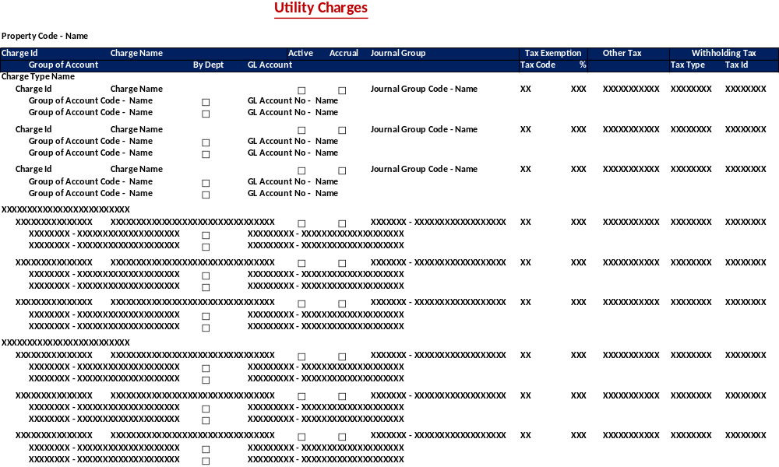
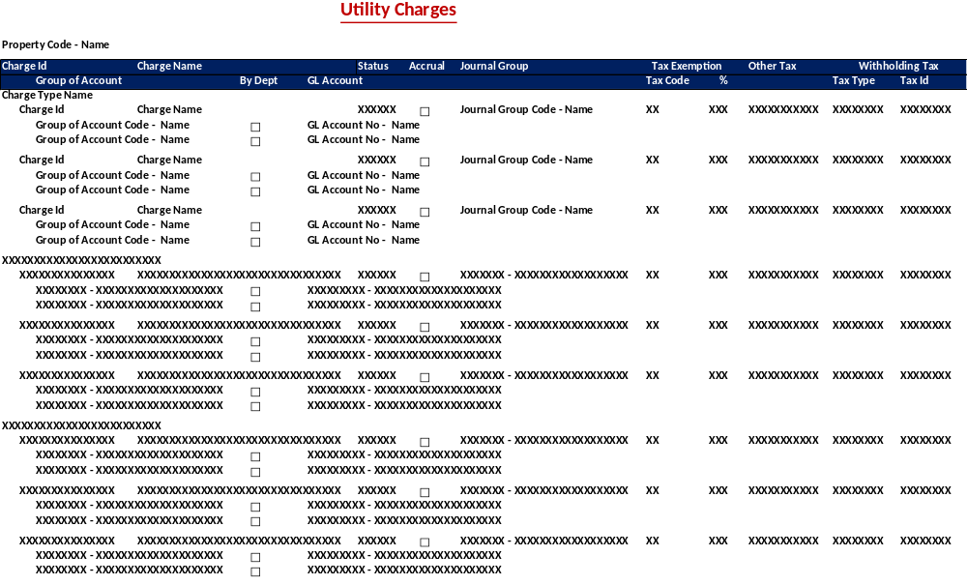

Test
- Print Utility Charges
Header
  - "Property"
    - Textbox
    - Field = CPROPERTY_ID - CPROPERTY_NAME

Detail
  - "Charges Id"
    - Textbox
    - Field = CCHARGES_ID

  - "Charges Name"
    - Textbox
    - Field = CCHARGES_NAME

  - "Charges Type Name"
    - Textbox
    - Field = CCHARGES_TYPE_DESCR
[CR05]
  - "Status"
    - Textbox
    - Field = CSTATUS_DESCRIPTION
  - "Active"
    - Checkbox
    - Field = LACTIVE
[CR05/]

  - "Accrual"
    - Textbox
    - Field = LACCRUAL

  - "Journal Group"
    - Textbox
    - Field = CSERVICE_JRNGRP_CODE - CSERVICE_JRNGRP_NAME

"Tax Exemption"
  - "Tax Code"
    - Textbox
    - Field = CTAX_EXEMPTION_CODE

  - "Tax %"
    - Textbox
    - Field = [CR06] ITAX_EXEMPTION_PCT NTAX_EXEMPTION_PCT

  - "Other Tax"
    - Textbox
    - Field = COTHER_TAX_ID

"Withholding Tax"
  - "Tax Type"
    - Textbox
    - Field = CWITHHOLDING_TAX_TYPE
  - "Tax Id"
    - Textbox
    - Field = CWITHHOLDING_TAX_ID

  - "Group of Account"
    - Textbox
    - Field = CGOA_CODE - CGOA_NAME

  - "By Dept"
    - Textbox
    - Field = LDEPARTMENT_MODE

  - "GL Account"
    - Textbox
    - Field = CGLACCOUNT_NO - CGLACCOUNT_NAME

TAB - RATE

ELECTRICITY and CHILLER

USER INTERFACE
[CR12]
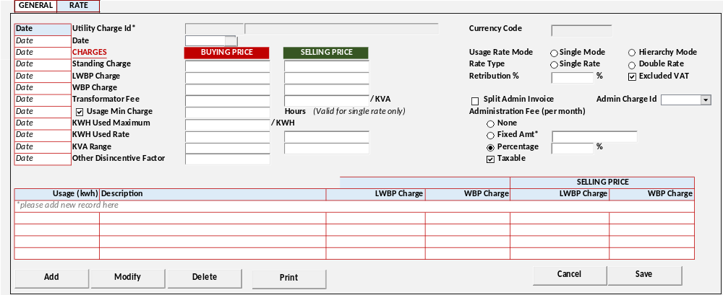

[CR10]
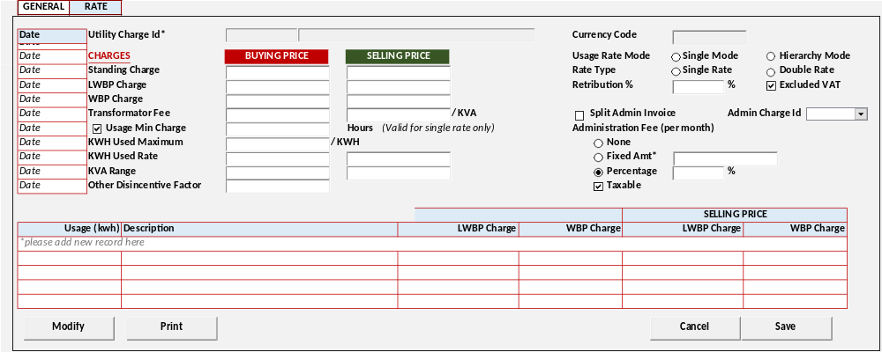

[CR09]
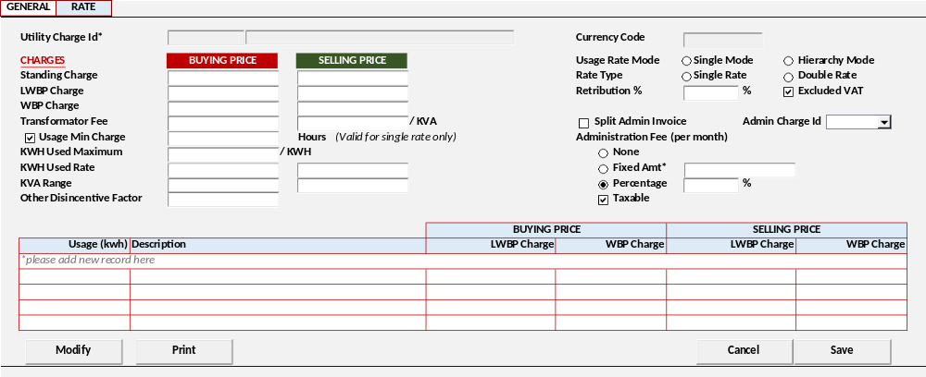

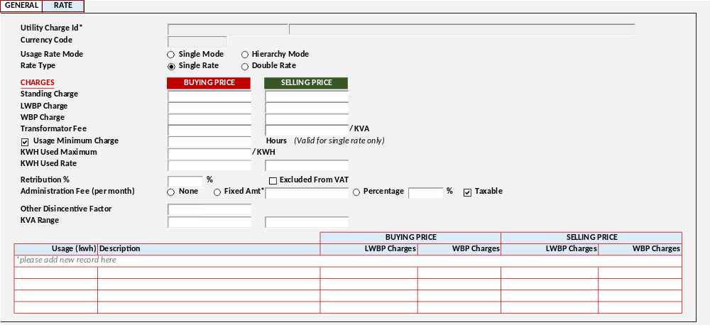

DISPLAY PROCESS
Test
[CR10]
Load Charges Rate Date [CHARGES_RATE_DATE]
EXEC RSP_PM_GET_CHARGES_UTILITY_RATE_EC_DATE @CCOMPANY_ID, @CPROPERTY_ID, @CCHARGE_TYPE_ID, @CCHARGES_ID, @CUSER_LOGIN_ID
  - "Date"
    - Textbox
    - Display = CCHARGES_DATE
[CR10/]

Load Charges Rate Detail [CHARGES_RATE_DETAIL]

EXEC RSP_PM_GET_CHARGES_UTILITY_RATE_EC @CCOMPANY_ID, @CPROPERTY_ID, @CCHARGE_TYPE_ID, @CCHARGES_ID, [CR10] @CCHARGES_DATE, @CUSER_LOGIN_ID

- Display data [CHARGES_RATE_DETAIL]:
  - "Utility Charge Id"
    - Textbox
    - Display = CCHARGES_ID, CCHARGES_NAME
    - VARCHAR(20), NVARCHAR(100)
    - Disabled
    - Saat Add / Modify Get data from
EXEC RSP_PM_GET_CHARGES_UTILITY_DETAIL @CCOMPANY_ID, @CPROPERTY_ID, @CCHARGE_TYPE_ID, @CCHARGES_ID, @CUSER_LOGIN_ID

  - "Currency Code"
    - Textbox Lookup
    - Display = CCURENCY_CODE
    - VARCHAR(3)
[CR13]
    - Value = Lookup GSL00300 – CURRENCY LOOKUP
With Parameter:
Login Company Id
Login User Id

    - Disabled
    - Saat Add / Modify Get data from
EXEC RSP_PM_GET_CHARGES_UTILITY_DETAIL @CCOMPANY_ID, @CPROPERTY_ID, @CCHARGE_TYPE_ID, @CCHARGES_ID, @CUSER_LOGIN_ID
[CR10]

  - "Date"
    - Datetime Picker
    - Display = CCHARGES_DATE
    - Default Value = Today Date
[CR10/]

  - "Usage Rate Mode"
    - Radio Button
    - Display = CUSAGE_RATE_MODE
    - Value =
SELECT CCODE, CDESCRIPTION FROM RFT_GET_GSB_CODE_INFO
('BIMASAKTI', [Login Company Id], '_USAGE_RATE_MODE', '', [Login Language Id])
    - Default – [HM] Hierarchy Mode

  - "Rate Type"
    - Radio Button
    - Display = CRATE_TYPE
    - Value =
SELECT CCODE, CDESCRIPTION FROM RFT_GET_GSB_CODE_INFO
('BIMASAKTI', [Login Company Id], '_RATE_TYPE', '', [Login Language Id])
    - Default – [SR] Single Rate

CHARGES
  - "Standing Charge"
    - Buying Price
      - Textbox
      - Display = NBUY_STANDING_CHARGE
      - Numeric Input Only

    - Selling Price
      - Textbox
      - Display = NSTANDING_CHARGE
      - Numeric Input Only

  - "LWBP Charge"
    - Buying Price
      - Textbox
      - Display = NBUY_LWBP_CHARGE
      - Numeric Input Only

    - Selling Price
      - Textbox
      - Display = NLWBP_CHARGE
      - Numeric Input Only

  - "WBP Charge"
    - Buying Price
      - Textbox
      - Display = NBUY_WBP_CHARGE
      - Numeric Input Only

    - Selling Price
      - Textbox
      - Display = NWBP_CHARGE
      - Numeric Input Only

  - "Transformator Fee"
    - Buying Price
      - Textbox
      - Display = NBUY_TRANSFORMATOR_FEE
      - Numeric Input Only

    - Selling Price
      - Textbox
      - Display = NTRANSFORMATOR_FEE
      - Numeric Input Only

  - "Usage Minimum Charge" Flag
    - Checkbox
    - Display = LUSAGE_MIN_CHARGE
    - Value = [0] Unchecked / [1] Checked
    - IF Checked, enable
      - "Usage Minimum Charge"
        - Textbox
        - Display = NUSAGE_MIN_CHARGE
        - Numeric Input Only

  - "KWH Used Maximum"
    - Textbox
    - Display = NKWH_USED_MAX
    - Numeric Input Only

  - "KWA Used Rate"
    - Buying Price
      - Textbox
      - Display = NBUY_KWA_USED_RATE
      - Numeric Input Only

    - Selling Price
      - Textbox
      - Display = NKWA_USED_RATE
      - Numeric Input Only

  - "Retribution %"
    - Textbox
    - Display = NRETRIBUTION_PCT
    - Numeric Input Only
    - Max = 100
    - Min = 0

  - "Excluded from VAT" Flag
    - Checkbox
    - Display = LRETRIBUTION_EXCLUDED_VAT
    - Value = [0] Unchecked / [1] Checked

  - [CR09] "Split Admin Invoice" Flag
    - Checkbox
    - Display = LSPLIT_ADMIN
    - Value = [0] Unchecked / [1] Checked
    - IF Checked, enable
      - "Admin Charge Id"
        - Combobox
        - Field = CADMIN_CHARGE_ID
        - Value =
RSP_PM_GET_CHARGES_UTILITY_LIST @CCOMPANY_ID, @CPROPERTY_ID, ‘09’, @CUSER_LOGIN_ID

  - "Administration Fee (per month)"
    - Radio Button
    - Display = CADMIN_FEE
    - Value =
SELECT CCODE, CDESCRIPTION FROM RFT_GET_GSB_CODE_INFO
('BIMASAKTI', [Login Company Id], '_ADMIN_FEE_TYPE', '', [Login Language Id])
    - [CR08] Default = '00' None
    - IF 02: Percentage, enable:
      - "Administration Fee percentage"
        - Display = NADMIN_FEE_PCT
        - Numeric Input Only
        - Max = 100
        - Min = 0
    - IF 01: Fixed Amount, enable:
      - "Administration Fee Fix Amount"
        - Display = NADMIN_FEE_AMT
        - Numeric Input Only
  - "Taxable"
    - Checkbox
    - Display = LADMIN_FEE_TAX
    - Value = [0] Unchecked / [1] Checked
    - Default = [0] Unchecked

  - "KWA Used Maximum"
    - Textbox
    - Display = NKWH_USED_MAX
    - Numeric Input Only
    - Max = 100
    - Min = 0

  - "Other Disincentive Factor"
    - Textbox
    - Display = NOTHER_DISINCENTIVE_FACTOR
    - Numeric Input Only

  - "KVA Range"
    - Buying Price
      - Textbox
      - Display = NBUY_KVA_RANGE
      - Numeric Input Only

    - Selling Price
      - Textbox
      - Display = NKVA_RANGE
      - Numeric Input Only

- Load Usage List [USAGE_LIST]
EXEC RSP_PM_GET_RATE_EC_LIST @CCOMPANY_ID, @CPROPERTY_ID, @CCHARGE_TYPE_ID, @CCHARGES_ID, @CUSER_LOGIN_ID
[CR08] Jika "Usage Rate Mode" = [SM] Single Mode set Usage List = Disabled

- Display data [USAGE_LIST]:
  - "Usage (KWH) Description"
    - Textbox
    - Display = IUP_TO_USAGE, CUSAGE_DESC
    - Int, NVARCHAR(255)

  - "BUYING PRICE"
    - "LWBP Charges"
      - Textbox
      - Display = NBUY_LWBP_CHARGE
      - Numeric Input
    - "WBP Charges"
      - Textbox
      - Display = NBUY_WBP_CHARGE
      - Numeric Input

  - "SELLING PRICE"
    - "LWBP Charges"
      - Textbox
      - Display = NLWBP_CHARGE
      - Numeric Input
    - "WBP Charges"
      - Textbox
      - Display = NWBP_CHARGE
      - Numeric Input

- Proses
        - "Add New" Go to ADD NEW PROCESS
        - "Edit" Go to EDIT PROCESS
        - "Delete" Go to DELETE PROCESS

ADD PROCESS
[CR12] | Test
- Set VAR_SAVE_MODE = ADD
- Enabled fields: All Field
- Disabled fields: "Charges Id", [CR13] "Currency"
- Set focus to column: "Charges Date"

- Proses
        - “Save” Go to SAVE & VALIDATION PROCESS
        - “Cancel” Go to DISPLAY PROCESS

EDIT PROCESS
[CR01] | Test
- Set VAR_SAVE_MODE = EDIT
- Enabled fields: All Field
- Disabled fields: "Charges Id",[CR13] "Currency", [CR10] "Charges Date"
- Set focus to column: "Usage Rate Mode"

- Proses
        - “Save” Go to SAVE & VALIDATION PROCESS
        - “Cancel” Go to DISPLAY PROCESS

DELETE PROCESS
[CR12] | Test
CREATE TABLE #CRATE_EC_LIST (NO INT
, CCOMPANY_ID VARCHAR(20)
, CPROPERTY_ID NVARCHAR(100)
, CCHARGES_TYPE NVARCHAR(100)
, CCHARGES_ID NVARCHAR(100)
, IUP_TO_USAGE INT
, CUSAGE_DESC NVARCHAR(100)
, NBUY_LWBP_CHARGE NUMERIC(18,2)
, NBUY_WBP_CHARGE NUMERIC(18,2)
, NLWBP_CHARGE NUMERIC(18,2)
, NWBP_CHARGE NUMERIC(18,2)
)

INSERT INTO #CRATE_EC_LIST

VALUES
[Login Company Id]
,[Selected Property Id]
, "Charges Type"
, "Charges Id*" Code
, "Usage (KWH)"
, "Description"
, "BUYING PRICE" - "LWBP Charges"
, "BUYING PRICE" - "WBP Charges"
, "SELLING PRICE" - "LWBP Charges"
, "SELLING PRICE" - "WBP Charges"

EXEC RSP_PM_MAINTAIN_RATE_EC
"Login Company Id"
, "Property Id"
, "Charges Type"
, "Charges Id*" Code
, "Charges Date"
, "Usage Rate Mode"
, "Rate Type"
, "Standing Charge" - Buying Price
, "Standing Charge" - Selling Price
, "LWBP Charge" - Buying Price
, "LWBP Charge" - Selling Price
, "WBP Charge" - Buying Price
, "WBP Charge" - Selling Price
, "Transformator Fee" - Buying Price
, "Transformator Fee" - Selling Price
, "Usage Minimum Charge" Flag
, "Usage Minimum Charge"
, "KWH Used Maximum"
, "KWA Used Rate" - Buying Price
, "KWA Used Rate" - Selling Price
, "Retribution %"
, "Excluded from VAT" Flag
, "Administration Fee (per month)"
, "Administration Fee percentage"
, "Administration Fee Fix Amount"
, "Taxable"
, "KWA Used Maximum"
, "Other Disincentive Factor"
, "KVA Range" - Buying Price
, "KVA Range" – Selling Price
, "Split Admin”
, Admin Charge Id”

, CACTION [DELETE]
, Login User Id
- Go to DISPLAY PROCESS

SAVE & VALIDATION PROCESS
[CR01] | Test
- Save Utility Rate
  - Electricity and Chiller
IF "Charges Type" = 01 Electricity / 02 Chiller
[CR03]
DECLARE @CRATE_EC_LIST AS RDT_COMMON_OBJECT

INSERT INTO @CRATE_EC_LIST (
COBJECT_ID, COBJECT_DESC, CATTRIBUTE01, CATTRIBUTE02, CATTRIBUTE03, CATTRIBUTE04, CATTRIBUTE05, CATTRIBUTE06, CATTRIBUTE07, CATTRIBUTE08)

CREATE TABLE #CRATE_EC_LIST (NO INT
, CCOMPANY_ID VARCHAR(20)
, CPROPERTY_ID NVARCHAR(100)
, CCHARGES_TYPE NVARCHAR(100)
, CCHARGES_ID NVARCHAR(100)
, IUP_TO_USAGE INT
, CUSAGE_DESC NVARCHAR(100)
, NBUY_LWBP_CHARGE NUMERIC(18,2)
, NBUY_WBP_CHARGE NUMERIC(18,2)
, NLWBP_CHARGE NUMERIC(18,2)
, NWBP_CHARGE NUMERIC(18,2)
)

INSERT INTO #CRATE_EC_LIST
[CR03]

VALUES
[Login Company Id]
,[Selected Property Id]
, "Charges Type"
, "Charges Id*" Code
, "Usage (KWH)"
, "Description"
, "BUYING PRICE" - "LWBP Charges"
, "BUYING PRICE" - "WBP Charges"
, "SELLING PRICE" - "LWBP Charges"
, "SELLING PRICE" - "WBP Charges"

EXEC RSP_PM_MAINTAIN_RATE_EC
"Login Company Id"
, "Property Id"
, "Charges Type"
, "Charges Id*" Code
[CR10], "Charges Date"
, "Usage Rate Mode"
, "Rate Type"
, "Standing Charge" - Buying Price
, "Standing Charge" - Selling Price
, "LWBP Charge" - Buying Price
, "LWBP Charge" - Selling Price
, "WBP Charge" - Buying Price
, "WBP Charge" - Selling Price
, "Transformator Fee" - Buying Price
, "Transformator Fee" - Selling Price
, "Usage Minimum Charge" Flag
, "Usage Minimum Charge"
, "KWH Used Maximum"
, "KWA Used Rate" - Buying Price
, "KWA Used Rate" - Selling Price
, "Retribution %"
, "Excluded from VAT" Flag
, "Administration Fee (per month)"
, "Administration Fee percentage"
, "Administration Fee Fix Amount"
, "Taxable"
, "KWA Used Maximum"
, "Other Disincentive Factor"
, "KVA Range" - Buying Price
, "KVA Range" – Selling Price
, [CR09] "Split Admin”
, [CR09] "Admin Charge Id”

, CACTION [ADD / EDIT]
, Login User Id
[CR03], @CRATE_EC_LIST
, [CR13] Currency Code
- Go to DISPLAY PROCESS

CANCEL PROCESS
[CR01] | Test
- Tutup program dan kembali ke Utility Charges – Tab Electricity and Chiller

PRINT PROCESS

USER INTERFACE
[CR10]
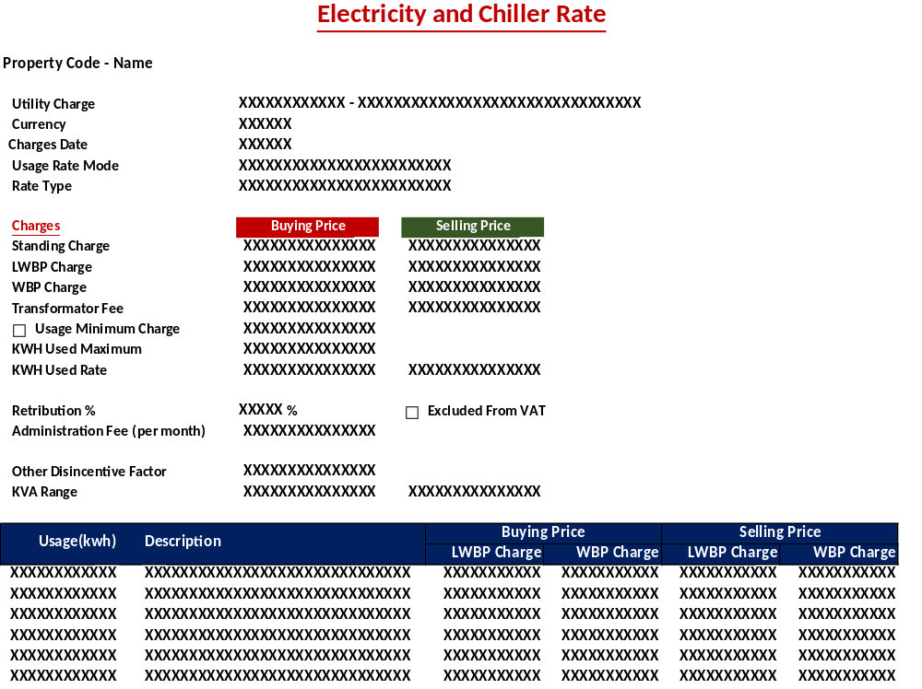
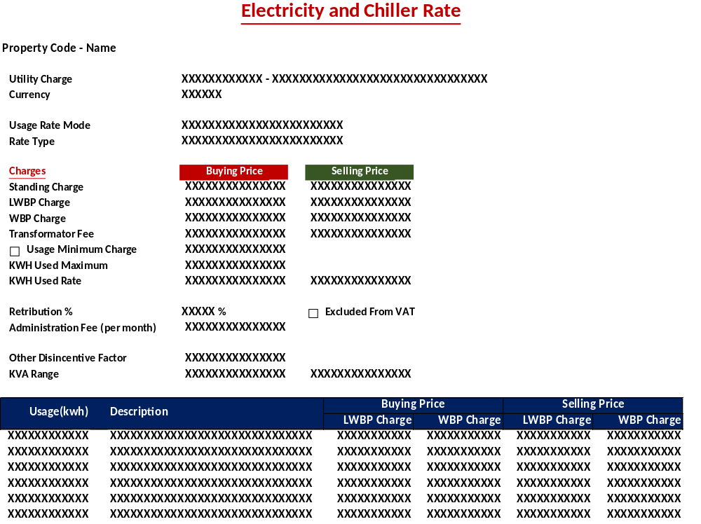

DISPLAY PROCESS
Test
Load Charges Rate Detail [CHARGES_RATE_DETAIL]

EXEC RSP_PM_GET_CHARGES_UTILITY_RATE_EC @CCOMPANY_ID, @CPROPERTY_ID, @CCHARGE_TYPE_ID, @CCHARGES_ID, @CUSER_LOGIN_ID

Display Header
  - "Property"
    - Textbox
    - Display = CPROPERTY_ID, CPROPERTY_NAME

- Display data [CHARGES_RATE_DETAIL]:
  - "Utility Charge"
    - Textbox
    - Display = CCHARGES_ID, CCHARGES_NAME

  - "Currency"
    - Textbox
    - Display = CCURENCY_CODE
[CR10]
  - "Date"
    - Textbox
    - Display = CCHARGES_DATE
[CR10/]

  - "Usage Rate Mode"
    - Textbox
    - Field = CUSAGE_RATE_MODE
    - Display = CUSAGE_RATE_MODE_DESCR

  - "Rate Type"
    - Textbox
    - Field = CRATE_TYPE
    - Display = CRATE_TYPE_DESCR

CHARGES
  - "Standing Charge"
    - Buying Price
      - Textbox
      - Display = NBUY_STANDING_CHARGE

    - Selling Price
      - Textbox
      - Display = NSTANDING_CHARGE

  - "LWBP Charge"
    - Buying Price
      - Textbox
      - Display = NBUY_LWBP_CHARGE

    - Selling Price
      - Textbox
      - Display = NLWBP_CHARGE

  - "WBP Charge"
    - Buying Price
      - Textbox
      - Display = NBUY_WBP_CHARGE
      - Numeric Input Only

    - Selling Price
      - Textbox
      - Display = NWBP_CHARGE

  - "Transformator Fee"
    - Buying Price
      - Textbox
      - Display = NBUY_TRANSFORMATOR_FEE

    - Selling Price
      - Textbox
      - Display = NTRANSFORMATOR_FEE

  - "Usage Minimum Charge" Flag
    - Checkbox
    - Display = LUSAGE_MIN_CHARGE
      - "Usage Minimum Charge"
        - Textbox
        - Display = NUSAGE_MIN_CHARGE

  - "KWH Used Maximum"
    - Textbox
    - Display = NKWH_USED_MAX

  - "KWH Used Rate"
    - Buying Price
      - Textbox
      - Display = NKWH_USED_RATE

    - Selling Price
      - Textbox
      - Display = NBUY_KWH_USED_RATE

  - "KWA Used Rate"
    - Buying Price
      - Textbox
      - Display = NBUY_KWA_USED_RATE

    - Selling Price
      - Textbox
      - Display = NKWA_USED_RATE

  - "Retribution %"
    - Textbox
    - Display = NRETRIBUTION_PCT

  - "Excluded from VAT" Flag
    - Checkbox
    - Display = LRETRIBUTION_EXCLUDED_VAT

  - "Administration Fee (per month)"
    - Textbox
    - Field = CADMIN_FEE
    - Display = CADMIN_FEE_DESCR
    - IF 02: Percentage, enable:
      - "Administration Fee percentage"
        - Display = NADMIN_FEE_PCT
    - IF 01: Fixed Amount, enable:
      - "Administration Fee Fix Amount"
        - Display = NADMIN_FEE_AMT
        - Numeric Input Only
  - "Taxable"
    - Checkbox
    - Display = LADMIN_FEE_TAX

  - "KWA Used Maximum"
    - Textbox
    - Display = NKWA_USED_RATE

  - "Other Disincentive Factor"
    - Textbox
    - Display = NOTHER_DISINCENTIVE_FACTOR

  - "KVA Range"
    - Buying Price
      - Textbox
      - Display = NBUY_KVA_RANGE

    - Selling Price
      - Textbox
      - Display = NKVA_RANGE

- Load Usage List [USAGE_LIST]
EXEC RSP_PM_GET_RATE_EC_LIST @CCOMPANY_ID, @CPROPERTY_ID, @CCHARGE_TYPE_ID, @CCHARGES_ID, @CUSER_LOGIN_ID

- Display data [USAGE_LIST]:
  - "Usage (KWH)"
    - Textbox
    - Display = IUP_TO_USAGE

  - " Description"
    - Textbox
    - Display = CUSAGE_DESC

  - "BUYING PRICE"
    - "LWBP Charges"
      - Textbox
      - Display = NBUY_LWBP_CHARGE
    - "WBP Charges"
      - Textbox
      - Display = NBUY_WBP_CHARGE

  - "SELLING PRICE"
    - "LWBP Charges"
      - Textbox
      - Display = NLWBP_CHARGE
    - "WBP Charges"
      - Textbox
      - Display = NWBP_CHARGE

WATER and GAS

USER INTERFACE
[CR12]
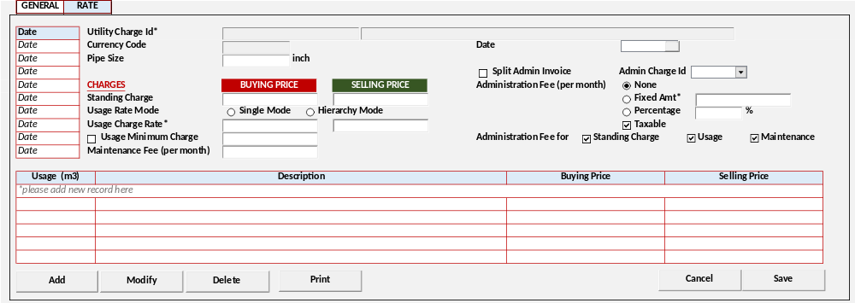
[CR10]
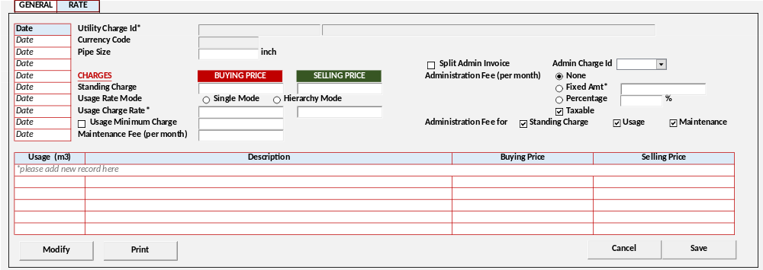
[CR09]
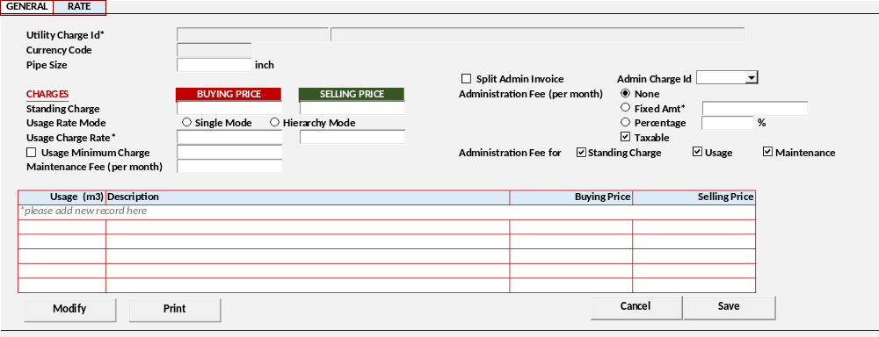
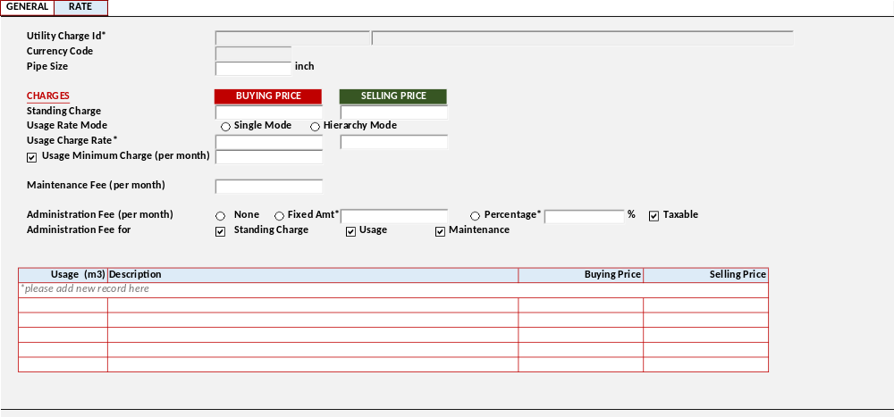

DISPLAY PROCESS
Test
[CR10]
Load Charges Rate Date [CHARGES_RATE_DATE]
EXEC RSP_PM_GET_CHARGES_UTILITY_RATE_WG_DATE @CCOMPANY_ID, @CPROPERTY_ID, @CCHARGE_TYPE_ID, @CCHARGES_ID, @CUSER_LOGIN_ID
  - "Date"
    - Textbox
    - Display = CCHARGES_DATE
[CR10/]

Load Charges Rate Detail [CHARGES_RATE_DETAIL]

EXEC RSP_PM_GET_CHARGES_UTILITY_RATE_WG @CCOMPANY_ID, @CPROPERTY_ID, @CCHARGE_TYPE_ID, @CCHARGES_ID, [CR10] @CCHARGES_DATE, @CUSER_LOGIN_ID

- Display data [CHARGES_RATE_DETAIL]:
  - "Utility Charge Id"
    - Textbox
    - Display = CCHARGES_ID, CCHARGES_NAME
    - VARCHAR(20), NVARCHAR(100)
    - Disabled

  - "Currency Code"
    - Textbox Lookup
    - Display = CCURENCY_CODE
    - VARCHAR(3)
[CR13]
    - Value = Lookup GSL00300 – CURRENCY LOOKUP
With Parameter:
Login Company Id
Login User Id

[CR10]

  - "Date"
    - Datetime Picker
    - Display = CCHARGES_DATE
    - Default Value = Today Date
[CR10/]

  - "Pipe Size"
    - Textbox
    - Display = NPIPE_SIZE
    - Numeric Input Only

CHARGES
  - "Standing Charge"
    - Buying Price
      - Textbox
      - Display = NBUY_STANDING_CHARGE
      - Numeric Input Only

    - Selling Price
      - Textbox
      - Display = NSTANDING_CHARGE
      - Numeric Input Only

  - "Usage Rate Mode"
    - Radio Button
    - Display = CUSAGE_RATE_MODE
    - Value =
SELECT CCODE, CDESCRIPTION FROM RFT_GET_GSB_CODE_INFO
('BIMASAKTI', [Login Company Id], '_USAGE_RATE_MODE', '', [Login Language Id])
    - Default – [HM] Hierarchy Mode

  - "Usage Charge Rate*"
    - Buying Price
      - Textbox
      - Display = NBUY_USAGE_CHARGE_RATE
      - Numeric Input Only

    - Selling Price
      - Textbox
      - Display = NUSAGE_CHARGE_RATE
      - Numeric Input Only

  - "Usage Minimum Charge (per month)"
    - Checkbox
    - Display = LUSAGE_MIN_CHARGE
    - Value = [0] Unchecked / [1] Checked
    - Default Value = [0] Unchecked
    - IF Checked, enabled:
      - "Usage Minimum Charge (per month)"
        - Textbox
        - Display = NUSAGE_MIN_CHARGE_AMT
        - Numeric Input Only

  - "Maintenance Fee (per month)"
    - Textbox
    - Display = NMAINTENANCE_FEE
    - Numeric Input Only

  - [CR09] "Split Admin Invoice" Flag
    - Checkbox
    - Display = LSPLIT_ADMIN
    - Value = [0] Unchecked / [1] Checked
    - IF Checked, enable
      - "Admin Charge Id"
        - Combobox
        - Field = CADMIN_CHARGE_ID
        - Value =
RSP_PM_GET_CHARGES_UTILITY_LIST @CCOMPANY_ID, @CPROPERTY_ID, ‘09’, @CUSER_LOGIN_ID

  - "Administration Fee (per month)"
    - Radio Button
    - Display = CADMIN_FEE
    - Value =
SELECT CCODE, CDESCRIPTION FROM RFT_GET_GSB_CODE_INFO
('BIMASAKTI', [Login Company Id], '_ADMIN_FEE_TYPE', '', [Login Language Id])
    - [CR08] Default = '00' None
    - IF 02: Percentage, enable:
      - "Administration Fee percentage"
        - Display = NADMIN_FEE_PCT
        - Numeric Input Only
        - Max = 100
        - Min = 0
    - IF 01: Fixed Amount, enable:
      - "Administration Fee Fix Amount"
        - Display = NADMIN_FEE_AMT
        - Numeric Input Only
  - "Taxable"
    - Checkbox
    - Display = LADMIN_FEE_TAX
    - Value = [0] Unchecked / [1] Checked
    - Default = [0] Unchecked

  - "Administration Fee For"
    - "Standing Charges"
      - Checkbox
      - Display = LADMIN_FEE_SC
      - Value = [0] Unchecked / [1] Checked
      - Default = [0] Unchecked

    - "Usage"
      - Checkbox
      - Display = LADMIN_FEE_USAGE
      - Value = [0] Unchecked / [1] Checked
      - Default = [0] Unchecked

    - "Maintenance"
      - Checkbox
      - Display = LADMIN_FEE_MAINTENANCE
      - Value = [0] Unchecked / [1] Checked
      - Default = [0] Unchecked

- Load Usage List [USAGE_LIST]
EXEC RSP_PM_GET_RATE_WG_LIST @CCOMPANY_ID, @CPROPERTY_ID, @CCHARGE_TYPE_ID, @CCHARGES_ID, @CUSER_LOGIN_ID

[CR08] Jika "Usage Rate Mode" = [SM] Single Mode set Usage List = Disabled
- Display data [USAGE_LIST]:
  - "Usage (m3)"
    - Textbox
    - Display = IUP_TO_USAGE
    - Int
    - Numeric Input Only
  - "Description"
    - Textbox
    - Display = CUSAGE_DESC
    - NVARCHAR(255)

  - "BUYING PRICE"
    - Textbox
    - Display = NBUY_USAGE_CHARGE
    - Numeric Input Only

  - "SELLING PRICE"
    - Textbox
    - Display = NUSAGE_CHARGE
    - Numeric Input Only

- Proses
        - "Add New" Go to ADD NEW PROCESS
        - "Edit" Go to EDIT PROCESS
        - "Delete" Go to DELETE PROCESS

ADD PROCESS
[CR12] | Test
- Set VAR_SAVE_MODE = ADD
- Enabled fields: All Field
- Disabled fields: "Charges Id", [CR13] "Currency"
- Set focus to column: "Charges Date"

- Proses
        - “Save” Go to SAVE & VALIDATION PROCESS
        - “Cancel” Go to DISPLAY PROCESS

EDIT PROCESS
[CR01] | Test
- Set VAR_SAVE_MODE = EDIT
- Enabled fields: All Field
- Disabled fields: "Charges Id", [CR13] "Currency" [CR10] Charges Date
- Set focus to column: "Pipe Size"

- Proses
        - “Save” Go to SAVE & VALIDATION PROCESS
        - “Cancel” Go to DISPLAY PROCESS

DELETE PROCESS
[CR12] | Test
- Delete Utility Rate
  - Water and Gas
IF "Charges Type" = 03 Water / 04 Gas

CREATE TABLE #CRATE_WG_LIST (CCOMPANY_ID VARCHAR(8)
, CPROPERTY_ID VARCHAR(20)
, CCHARGES_TYPE VARCHAR(2)
, CCHARGES_ID VARCHAR(20)
, IUP_TO_USAGE INT
, CUSAGE_DESC NVARCHAR(255)
, NUSAGE_CHARGE NUMERIC(18,2)
, NBUY_USAGE_CHARGE NUMERIC(18,2)
)
INSERT INTO #CRATE_WG_LIST
VALUES
[Login Company Id]
,[Selected Property Id]
, "Charges Type"
, "Charges Id*" Code
, "Usage (m3)"
, "Description"
, "BUYING PRICE"
, "SELLING PRICE"

EXEC RSP_PM_MAINTAIN_RATE_WG
"Login Company Id"
, "Property Id"
, "Charges Type"
, "Charges Id*" Code
, "Charges Date"
, "Pipe Size"
, "Standing Charge" - Buying Price
, "Standing Charge" - Selling Price
, "Usage Rate Mode"
, "Usage Charge Rate*"
, "Usage Minimum Charge (per month)" Flag
, "Usage Minimum Charge (per month)"
, "Maintenance Fee (per month)"
, "Administration Fee (per month)"
, "Administration Fee percentage"
, "Administration Fee Fix Amount"
, "Taxable"
, "Administration Fee For" - "Standing Charges"
, "Administration Fee For" - "Usage"
, "Administration Fee For" - "Maintenance"
, "Split Admin”
, "Admin Charge Id”

, CACTION [DELETE]
, Login User Id

- Go to DISPLAY PROCESS

SAVE & VALIDATION PROCESS
[CR01] | Test
- Save Utility Rate
  - Water and Gas
IF "Charges Type" = 03 Water / 04 Gas
[CR03]
DECLARE @CRATE_WG_LIST AS RDT_COMMON_OBJECT

INSERT INTO @CRATE_WG_LIST (
COBJECT_ID, COBJECT_DESC, CATTRIBUTE01, CATTRIBUTE02, CATTRIBUTE03, CATTRIBUTE04, CATTRIBUTE05, CATTRIBUTE06)

CREATE TABLE #CRATE_WG_LIST (CCOMPANY_ID VARCHAR(8)
, CPROPERTY_ID VARCHAR(20)
, CCHARGES_TYPE VARCHAR(2)
, CCHARGES_ID VARCHAR(20)
, IUP_TO_USAGE INT
, CUSAGE_DESC NVARCHAR(255)
, NUSAGE_CHARGE NUMERIC(18,2)
, NBUY_USAGE_CHARGE NUMERIC(18,2)
)
INSERT INTO #CRATE_WG_LIST
[CR03]
VALUES
[Login Company Id]
,[Selected Property Id]
, "Charges Type"
, "Charges Id*" Code
, "Usage (m3)"
, "Description"
, "BUYING PRICE"
, "SELLING PRICE"

EXEC RSP_PM_MAINTAIN_RATE_WG
"Login Company Id"
, "Property Id"
, "Charges Type"
, "Charges Id*" Code
[CR03], "Charges Date"
, "Pipe Size"
, "Standing Charge" - Buying Price
, "Standing Charge" - Selling Price
, "Usage Rate Mode"
, "Usage Charge Rate*"
, "Usage Minimum Charge (per month)" Flag
, "Usage Minimum Charge (per month)"
, "Maintenance Fee (per month)"
, "Administration Fee (per month)"
, "Administration Fee percentage"
, "Administration Fee Fix Amount"
, "Taxable"
, "Administration Fee For" - "Standing Charges"
, "Administration Fee For" - "Usage"
, "Administration Fee For" - "Maintenance"
, [CR09] "Split Admin”
, [CR09] "Admin Charge Id”

, CACTION [ADD / EDIT]
, Login User Id
[CR03], @CRATE_WG_LIST
, [CR13] Currency Code
- Go to DISPLAY PROCESS

CANCEL PROCESS
[CR01] | Test
- Tutup program dan kembali ke Utility Charges - Tab Rate Water and Gas

PRINT PROCESS

USER INTERFACE
[CR10]
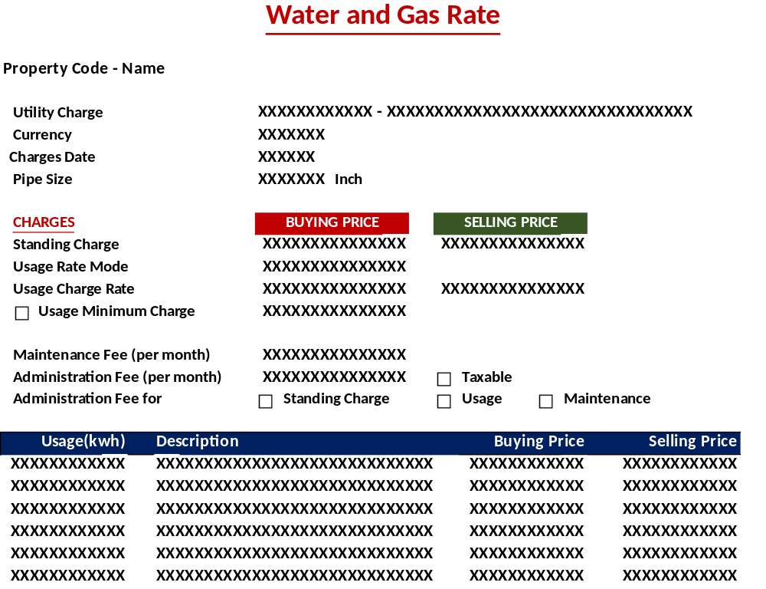
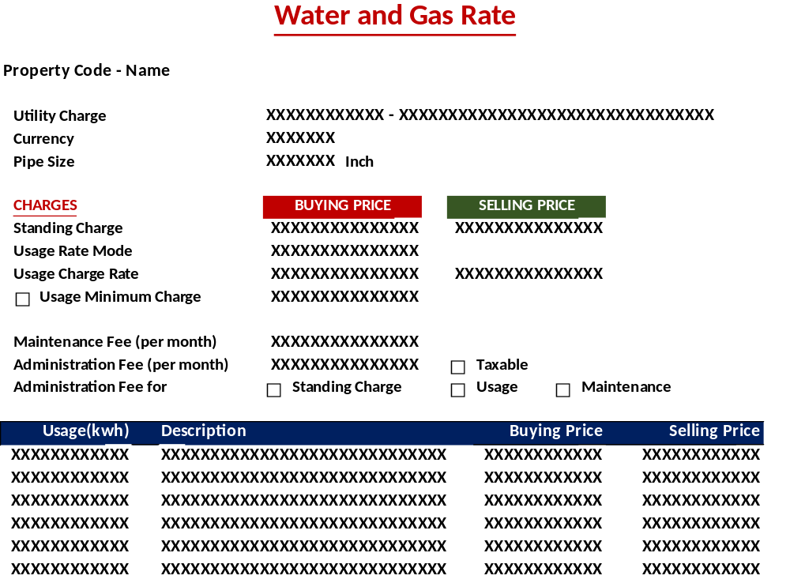

DISPLAY PROCESS
Test
Load Charges Rate Detail [CHARGES_RATE_DETAIL]

EXEC RSP_PM_GET_CHARGES_UTILITY_RATE_WG @CCOMPANY_ID, @CPROPERTY_ID, @CCHARGE_TYPE_ID, @CCHARGES_ID, @CUSER_LOGIN_ID

- Display data [CHARGES_RATE_DETAIL]:
  - "Utility Charge Id"
    - Textbox
    - Display = CCHARGES_ID, CCHARGES_NAME

  - "Currency Code"
    - Textbox
    - Display = CCURENCY_CODE
[CR10]
  - "Date"
    - Textbox
    - Display = CCHARGES_DATE
[CR10/]

  - "Pipe Size"
    - Textbox
    - Display = NPIPE_SIZE

CHARGES
  - "Standing Charge"
    - Buying Price
      - Textbox
      - Display = NBUY_STANDING_CHARGE

    - Selling Price
      - Textbox
      - Display = NSTANDING_CHARGE

  - "Usage Rate Mode"
    - Textbox
    - Field = CUSAGE_RATE_MODE
    - Display = CUSAGE_RATE_MODE_DESCR

  - "Usage Charge Rate*"
    - Buying Price
      - Textbox
      - Display = NBUY_USAGE_CHARGE_RATE

    - Selling Price
      - Textbox
      - Display = NUSAGE_CHARGE_RATE

  - "Usage Minimum Charge (per month)"
    - Checkbox
    - Display = LUSAGE_MIN_CHARGE
    - Value = [0] Unchecked / [1] Checked
      - "Usage Minimum Charge (per month)"
        - Textbox
        - Display = NUSAGE_MIN_CHARGE_AMT

  - "Maintenance Fee (per month)"
    - Textbox
    - Display = NMAINTENANCE_FEE

  - "Administration Fee (per month)"
    - Textbox
    - Field = CADMIN_FEE
    - Display = CADMIN_FEE_DESCR
    - IF 02: Percentage, enable:
      - "Administration Fee percentage"
        - Display = NADMIN_FEE_PCT
    - IF 01: Fixed Amount, enable:
      - "Administration Fee Fix Amount"
        - Display = NADMIN_FEE_AMT
  - "Taxable"
    - Checkbox
    - Display = LADMIN_FEE_TAX
    - Value = [0] Unchecked / [1] Checked

  - "Administration Fee For"
    - "Standing Charges"
      - Checkbox
      - Display = LADMIN_FEE_SC
      - Value = [0] Unchecked / [1] Checked

    - "Usage"
      - Checkbox
      - Display = LADMIN_FEE_USAGE
      - Value = [0] Unchecked / [1] Checked

    - "Maintenance"
      - Checkbox
      - Display = LADMIN_FEE_MAINTENANCE
      - Value = [0] Unchecked / [1] Checked

- Load Usage List [USAGE_LIST]
EXEC RSP_PM_GET_RATE_WG_LIST @CCOMPANY_ID, @CPROPERTY_ID, @CCHARGE_TYPE_ID, @CCHARGES_ID, @CUSER_LOGIN_ID

- Display data [USAGE_LIST]:
  - "Usage (m3)"
    - Textbox
    - Display = IUP_TO_USAGE

  - "Description"
    - Textbox
    - Display = CUSAGE_DESC

  - "BUYING PRICE"
    - Textbox
    - Display = NBUY_USAGE_CHARGE

  - "SELLING PRICE"
    - Textbox
    - Display = NUSAGE_CHARGE

PARKING and GENERAL FIXED

USER INTERFACE
[CR12]
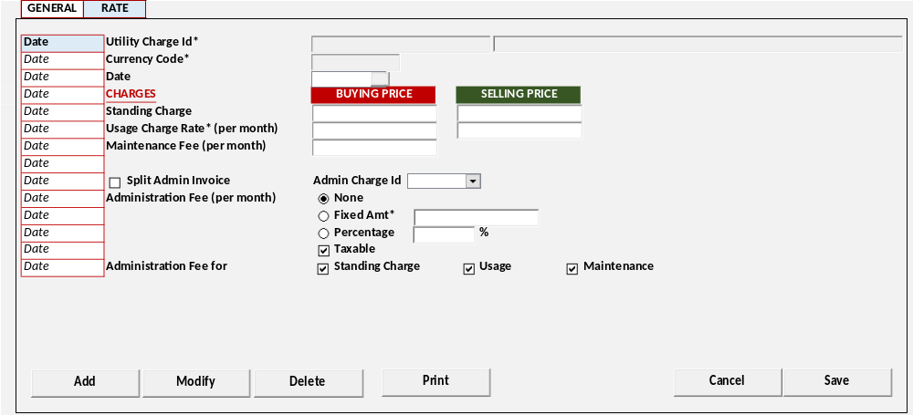
[CR10]
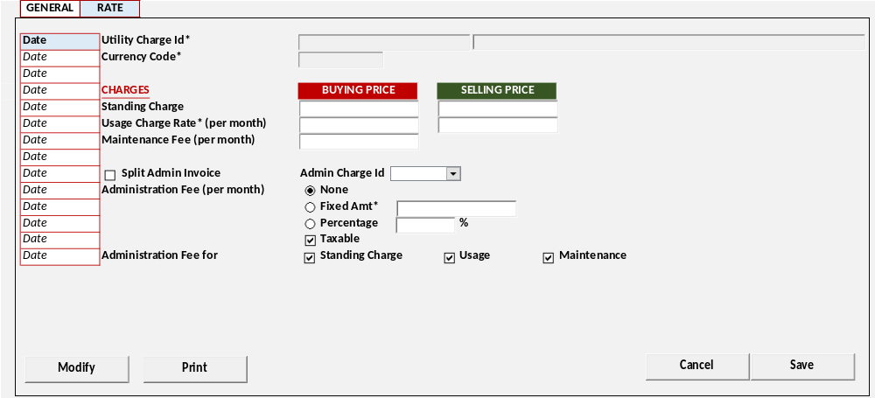
[CR09]
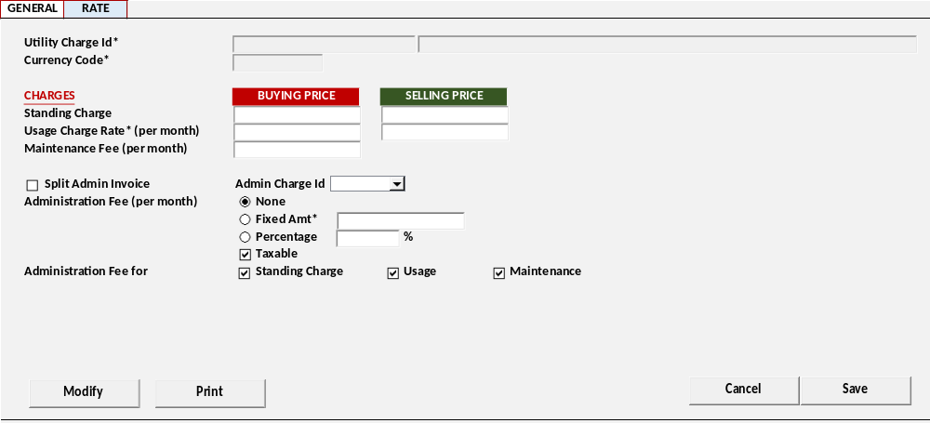
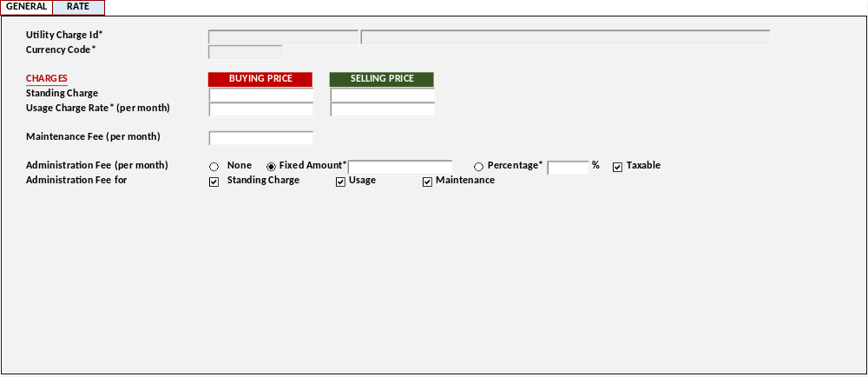

DISPLAY PROCESS
Test
[CR10]
Load Charges Rate Date [CHARGES_RATE_DATE]
EXEC RSP_PM_GET_CHARGES_UTILITY_RATE_PG_DATE @CCOMPANY_ID, @CPROPERTY_ID, @CCHARGE_TYPE_ID, @CCHARGES_ID, @CUSER_LOGIN_ID
  - "Date"
    - Textbox
    - Display = CCHARGES_DATE
[CR10/]

Load Charges Rate Detail [CHARGES_RATE_DETAIL]

EXEC RSP_PM_GET_CHARGES_UTILITY_RATE_PG @CCOMPANY_ID, @CPROPERTY_ID, @CCHARGE_TYPE_ID, @CCHARGES_ID, [CR10] @CCHARGES_DATE, @CUSER_LOGIN_ID

- Display data [CHARGES_RATE_DETAIL]:
  - "Utility Charge Id"
    - Textbox
    - Display = CCHARGES_ID, CCHARGES_NAME
    - VARCHAR(20), NVARCHAR(100)
    - Disabled

  - "Currency Code"
    - Textbox Lookup
    - Display = CCURENCY_CODE
    - VARCHAR(3)
[CR13]
    - Value = Lookup GSL00300 – CURRENCY LOOKUP
With Parameter:
Login Company Id
Login User Id

[CR10]
  - "Date"
    - Datetime Picker
    - Display = CCHARGES_DATE
    - Default Value = Today Date
[CR10/]

CHARGES
  - "Standing Charge"
    - Buying Price
      - Textbox
      - Display = NBUY_STANDING_CHARGE
      - Numeric Input Only

    - Selling Price
      - Textbox
      - Display = NSTANDING_CHARGE
      - Numeric Input Only

  - "Usage Charge Rate*"
    - Buying Price
      - Textbox
      - Display = NBUY_USAGE_CHARGE_RATE
      - Numeric Input Only

    - Selling Price
      - Textbox
      - Display = NUSAGE_CHARGE_RATE
      - Numeric Input Only

  - "Maintenance Fee (per month)"
    - Textbox
    - Display = NMAINTENANCE_FEE
    - Numeric Input Only

  - [CR09] "Split Admin Invoice" Flag
    - Checkbox
    - Display = LSPLIT_ADMIN
    - Value = [0] Unchecked / [1] Checked
    - IF Checked, enable
      - "Admin Charge Id"
        - Combobox
        - Field = CADMIN_CHARGE_ID
        - Value =
RSP_PM_GET_CHARGES_UTILITY_LIST @CCOMPANY_ID, @CPROPERTY_ID, ‘09’, @CUSER_LOGIN_ID

  - "Administration Fee (per month)"
    - Radio Button
    - Display = CADMIN_FEE
    - Value =
SELECT CCODE, CDESCRIPTION FROM RFT_GET_GSB_CODE_INFO
('BIMASAKTI', [Login Company Id], '_ADMIN_FEE_TYPE', '', [Login Language Id])
    - [CR08] Default = '00' None
    - IF 02: Percentage, enable:
      - "Administration Fee percentage"
        - Display = NADMIN_FEE_PCT
        - Numeric Input Only
        - Max = 100
        - Min = 0
    - IF 01: Fixed Amount, enable:
      - "Administration Fee Fix Amount"
        - Display = NADMIN_FEE_AMT
        - Numeric Input Only
  - "Taxable"
    - Checkbox
    - Display = LADMIN_FEE_TAX
    - Value = [0] Unchecked / [1] Checked
    - Default = [0] Unchecked

  - "Administration Fee For"
    - "Standing Charges"
      - Checkbox
      - Display = LADMIN_FEE_SC
      - Value = [0] Unchecked / [1] Checked
      - Default = [0] Unchecked

    - "Usage"
      - Checkbox
      - Display = LADMIN_FEE_USAGE
      - Value = [0] Unchecked / [1] Checked
      - Default = [0] Unchecked

    - "Maintenance"
      - Checkbox
      - Display = LADMIN_FEE_MAINTENANCE
      - Value = [0] Unchecked / [1] Checked
      - Default = [0] Unchecked

- Proses
        - "Add New" Go to ADD NEW PROCESS
        - "Edit" Go to EDIT PROCESS
        - "Delete" Go to DELETE PROCESS

ADD PROCESS
[CR12] | Test
- Set VAR_SAVE_MODE = ADD
- Enabled fields: All Field
- Disabled fields: "Charges Id", [CR13] "Currency"
- Set focus to column: "Charges Date"

- Proses
        - “Save” Go to SAVE & VALIDATION PROCESS
        - “Cancel” Go to DISPLAY PROCESS

EDIT PROCESS
[CR01] | Test
- Set VAR_SAVE_MODE = EDIT
- Enabled fields: All Field
- Disabled fields: "Charges Id", [CR13] "Currency", [CR10] "Charges Date"
- Set focus to column: Buying Price "Standing Charge"

- Proses
        - “Save” Go to SAVE & VALIDATION PROCESS
        - “Cancel” Go to DISPLAY PROCESS

DELETE PROCESS
[CR23] | Test
- Save Utility Rate

  - Parking and General Fixed
IF "Charges Type" = 05 Parking / 06 General (Fixed)
EXEC RSP_PM_MAINTAIN_RATE_PG
"Login Company Id"
, "Property Id"
, "Charges Type"
, "Charges Id*" Code
, "Charges Date"
, "Standing Charge" - Buying Price
, "Standing Charge" - Selling Price
, "Usage Charge Rate*" - Buying Price
, "Usage Charge Rate*" - Selling Price
, "Maintenance Fee (per month)"
, "Administration Fee (per month)"
, "Administration Fee percentage"
, "Administration Fee Fix Amount"
, "Taxable"
, "Administration Fee For" - "Standing Charges"
, "Administration Fee For" - "Usage"
, "Administration Fee For" - "Maintenance"
, "Split Admin”
, "Admin Charge Id”

, CACTION [DELETE]
, Login User Id

- Go to DISPLAY PROCESS

SAVE & VALIDATION PROCESS
[CR01] | Test
- Save Utility Rate

  - Parking and General Fixed
IF "Charges Type" = 05 Parking / 06 General (Fixed)
EXEC RSP_PM_MAINTAIN_RATE_PG
"Login Company Id"
, "Property Id"
, "Charges Type"
, "Charges Id*" Code
[CR10] , "Charges Date"
, "Standing Charge" - Buying Price
, "Standing Charge" - Selling Price
, "Usage Charge Rate*" - Buying Price
, "Usage Charge Rate*" - Selling Price
, "Maintenance Fee (per month)"
, "Administration Fee (per month)"
, "Administration Fee percentage"
, "Administration Fee Fix Amount"
, "Taxable"
, "Administration Fee For" - "Standing Charges"
, "Administration Fee For" - "Usage"
, "Administration Fee For" - "Maintenance"
, [CR09] "Split Admin”
, [CR09] "Admin Charge Id”

, CACTION [ADD / EDIT]
, Login User Id
, [CR13] Currency Code
- Go to DISPLAY PROCESS

CANCEL PROCESS
[CR01] | Test
- Tutup program dan kembali ke Utility Charges - Tab Rate Parking and General Fixed

PRINT PROCESS

USER INTERFACE
[CR10]
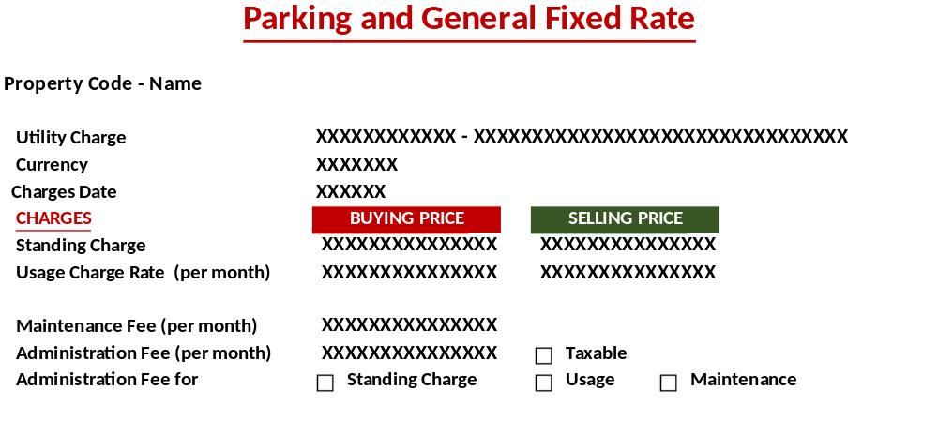
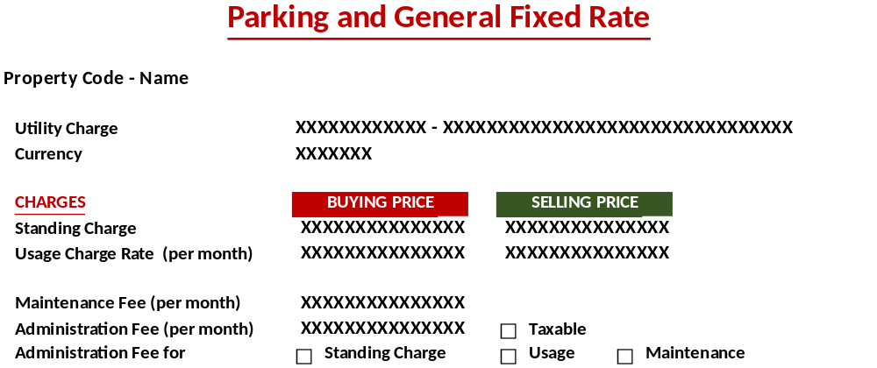

DISPLAY PROCESS
Test
Load Charges Rate Detail [CHARGES_RATE_DETAIL]

EXEC RSP_PM_GET_CHARGES_UTILITY_RATE_PG @CCOMPANY_ID, @CPROPERTY_ID, @CCHARGE_TYPE_ID, @CCHARGES_ID, @CUSER_LOGIN_ID

- Display data [CHARGES_RATE_DETAIL]:
  - "Utility Charge Id"
    - Textbox
    - Display = CCHARGES_ID, CCHARGES_NAME

  - "Currency Code"
    - Textbox
    - Display = CCURRENCY_CODE
[CR10]
  - "Date"
    - Textbox
    - Display = CCHARGES_DATE
[CR10/]

CHARGES
  - "Standing Charge"
    - Buying Price
      - Textbox
      - Display = NBUY_STANDING_CHARGE

    - Selling Price
      - Textbox
      - Display = NSTANDING_CHARGE

  - "Usage Charge Rate*"
    - Buying Price
      - Textbox
      - Display = NBUY_USAGE_CHARGE_RATE

    - Selling Price
      - Textbox
      - Display = NUSAGE_CHARGE_RATE

  - "Maintenance Fee (per month)"
    - Textbox
    - Display = NMAINTENANCE_FEE

  - "Administration Fee (per month)"
    - Radio Button
    - Field = CADMIN_FEE
    - Display = CADMIN_FEE_DESCR
    - IF 02: Percentage, enable:
      - "Administration Fee percentage"
        - Display = NADMIN_FEE_PCT
    - IF 01: Fixed Amount, enable:
      - "Administration Fee Fix Amount"
        - Display = NADMIN_FEE_AMT
  - "Taxable"
    - Checkbox
    - Display = LADMIN_FEE_TAX
    - Value = [0] Unchecked / [1] Checked

  - "Administration Fee For"
    - "Standing Charges"
      - Checkbox
      - Display = LADMIN_FEE_SC
      - Value = [0] Unchecked / [1] Checked

    - "Usage"
      - Checkbox
      - Display = LADMIN_FEE_USAGE
      - Value = [0] Unchecked / [1] Checked

    - "Maintenance"
      - Checkbox
      - Display = LADMIN_FEE_MAINTENANCE
      - Value = [0] Unchecked / [1] Checked

GENERAL USAGE

USER INTERFACE
[CR12]
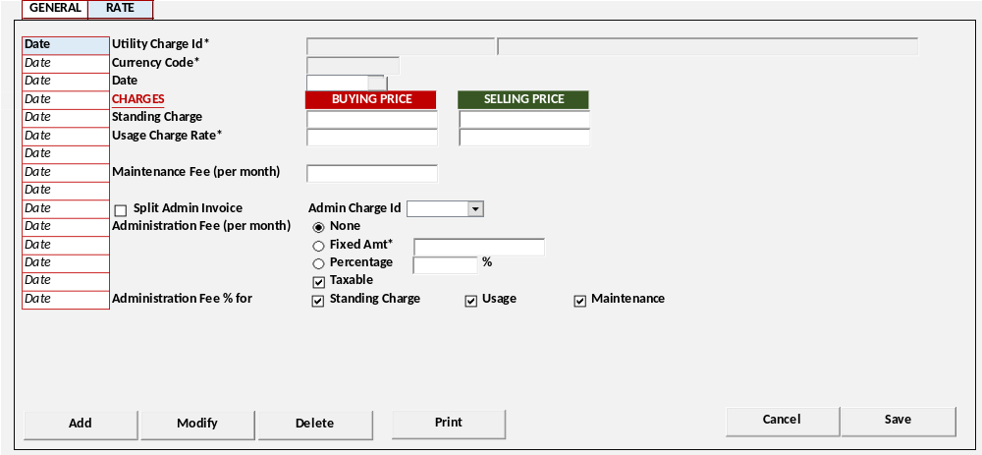
[CR10]
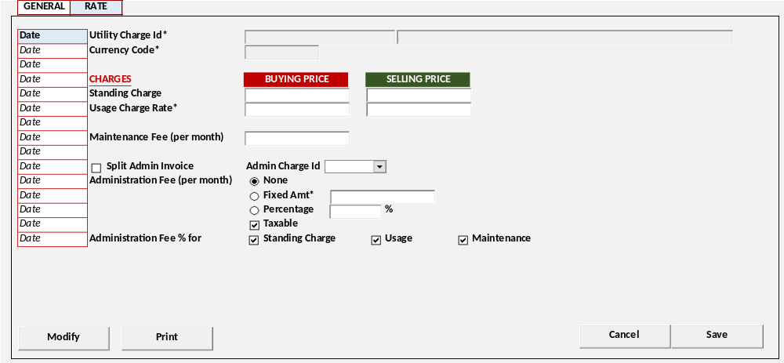
[CR09]
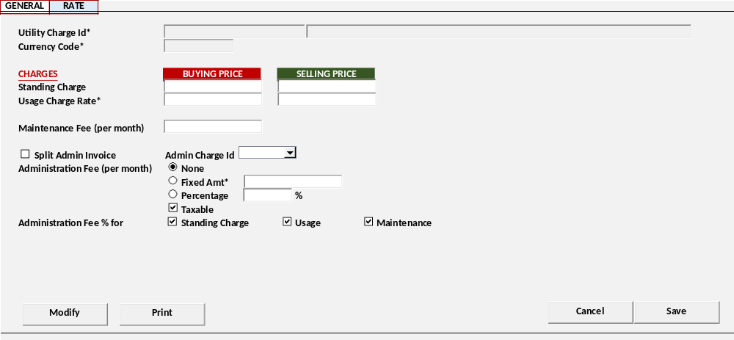
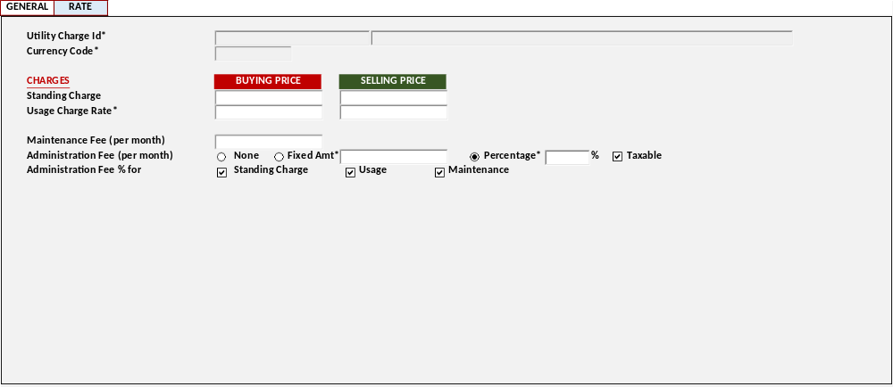

DISPLAY PROCESS
Test
[CR10]
Load Charges Rate Date [CHARGES_RATE_DATE]
EXEC RSP_PM_GET_CHARGES_UTILITY_RATE_GU_DATE @CCOMPANY_ID, @CPROPERTY_ID, @CCHARGE_TYPE_ID, @CCHARGES_ID, @CUSER_LOGIN_ID
  - "Date"
    - Textbox
    - Display = CCHARGES_DATE
[CR10/]

Load Charges Rate Detail [CHARGES_RATE_DETAIL]

EXEC RSP_PM_GET_CHARGES_UTILITY_RATE_GU @CCOMPANY_ID, @CPROPERTY_ID, @CCHARGE_TYPE_ID, @CCHARGES_ID, [CR10] @CCHARGES_DATE, @CUSER_LOGIN_ID

- Display data [CHARGES_RATE_DETAIL]:
  - "Utility Charge Id"
    - Textbox
    - Display = CCHARGES_ID, CCHARGES_NAME
    - VARCHAR(20), NVARCHAR(100)
    - Disabled

  - "Currency Code"
    - Textbox Lookup
    - Display = CCURENCY_CODE
    - VARCHAR(3)
[CR13]
    - Value = Lookup GSL00300 – CURRENCY LOOKUP
With Parameter:
Login Company Id
Login User Id

[CR10]
  - "Date"
    - Datetime Picker
    - Display = CCHARGES_DATE
    - Default Value = Today Date
[CR10/]

CHARGES
  - "Standing Charge"
    - Buying Price
      - Textbox
      - Display = NBUY_STANDING_CHARGE
      - Numeric Input Only

    - Selling Price
      - Textbox
      - Display = NSTANDING_CHARGE
      - Numeric Input Only

  - "Usage Charge Rate*"
    - Buying Price
      - Textbox
      - Display = NBUY_USAGE_CHARGE_RATE
      - Numeric Input Only

    - Selling Price
      - Textbox
      - Display = NUSAGE_CHARGE_RATE
      - Numeric Input Only

  - "Maintenance Fee (per month)"
    - Textbox
    - Display = NMAINTENANCE_FEE
    - Numeric Input Only

  - [CR09] "Split Admin Invoice" Flag
    - Checkbox
    - Display = LSPLIT_ADMIN
    - Value = [0] Unchecked / [1] Checked
    - IF Checked, enable
      - "Admin Charge Id"
        - Combobox
        - Field = CADMIN_CHARGE_ID
        - Value =
RSP_PM_GET_CHARGES_UTILITY_LIST @CCOMPANY_ID, @CPROPERTY_ID, ‘09’, @CUSER_LOGIN_ID

  - "Administration Fee (per month)"
    - Radio Button
    - Display = CADMIN_FEE
    - Value =
SELECT CCODE, CDESCRIPTION FROM RFT_GET_GSB_CODE_INFO
('BIMASAKTI', [Login Company Id], '_ADMIN_FEE_TYPE', '', [Login Language Id])
    - [CR08] Default = '00' None
    - IF 02: Percentage, enable:
      - "Administration Fee percentage"
        - Display = NADMIN_FEE_PCT
        - Numeric Input Only
        - Max = 100
        - Min = 0
    - IF 01: Fixed Amount, enable:
      - "Administration Fee Fix Amount"
        - Display = NADMIN_FEE_AMT
        - Numeric Input Only
  - "Taxable"
    - Checkbox
    - Display = LADMIN_FEE_TAX
    - Value = [0] Unchecked / [1] Checked
    - Default = [0] Unchecked

  - "Administration Fee For"
    - "Standing Charges"
      - Checkbox
      - Display = LADMIN_FEE_SC
      - Value = [0] Unchecked / [1] Checked
      - Default = [0] Unchecked

    - "Usage"
      - Checkbox
      - Display = LADMIN_FEE_USAGE
      - Value = [0] Unchecked / [1] Checked
      - Default = [0] Unchecked

    - "Maintenance"
      - Checkbox
      - Display = LADMIN_FEE_MAINTENANCE
      - Value = [0] Unchecked / [1] Checked
      - Default = [0] Unchecked

- Proses
        - "Add New" Go to ADD NEW PROCESS
        - "Edit" Go to EDIT PROCESS
        - "Delete" Go to DELETE PROCESS

EDIT PROCESS
[CR01] | Test
- Set VAR_SAVE_MODE = EDIT
- Enabled fields: All Field
- Disabled fields: "Charges Id",[CR13] "Currency" , [CR10] "Charges Date"
- Set focus to column: Buying Price "Standing Charge"

- Proses
        - “Save” Go to SAVE & VALIDATION PROCESS
        - “Cancel” Go to DISPLAY PROCESS

DELETE PROCESS
[CR12] | Test
- Delete Utility Rate
  - General Usage
IF "Charges Type" = 07 General (Usage)

EXEC RSP_PM_MAINTAIN_RATE_GU
"Login Company Id"
, "Property Id"
, "Charges Type"
, "Charges Id*" Code
, "Charges Date"
, "Standing Charge" - Buying Price
, "Standing Charge" - Selling Price
, "Usage Charge Rate*" - Buying Price
, "Usage Charge Rate*" - Selling Price
, "Maintenance Fee (per month)"
, "Administration Fee (per month)"
, "Administration Fee percentage"
, "Administration Fee Fix Amount"
, "Taxable"
, "Administration Fee For" - "Standing Charges"
, "Administration Fee For" - "Usage"
, "Administration Fee For" - "Maintenance"
, "Split Admin”
, "Admin Charge Id”
, CACTION [DELETE]
, Login User Id

- Go to DISPLAY PROCESS

SAVE & VALIDATION PROCESS
[CR01] | Test
- Save Utility Rate
  - General Usage
IF "Charges Type" = 07 General (Usage)
EXEC RSP_PM_MAINTAIN_RATE_GU
"Login Company Id"
, "Property Id"
, "Charges Type"
, "Charges Id*" Code
[CR10], "Charges Date"
, "Standing Charge" - Buying Price
, "Standing Charge" - Selling Price
, "Usage Charge Rate*" - Buying Price
, "Usage Charge Rate*" - Selling Price
, "Maintenance Fee (per month)"
, "Administration Fee (per month)"
, "Administration Fee percentage"
, "Administration Fee Fix Amount"
, "Taxable"
, "Administration Fee For" - "Standing Charges"
, "Administration Fee For" - "Usage"
, "Administration Fee For" - "Maintenance"
, [CR09] "Split Admin”
, [CR09] "Admin Charge Id”

, CACTION [ADD / EDIT]
, Login User Id
, [CR13] Currency Code
- Go to DISPLAY PROCESS

CANCEL PROCESS
[CR01] | Test
- Tutup program dan kembali ke Utility Charges - Tab Rate General Usage

PRINT PROCESS

USER INTERFACE
[CR10]

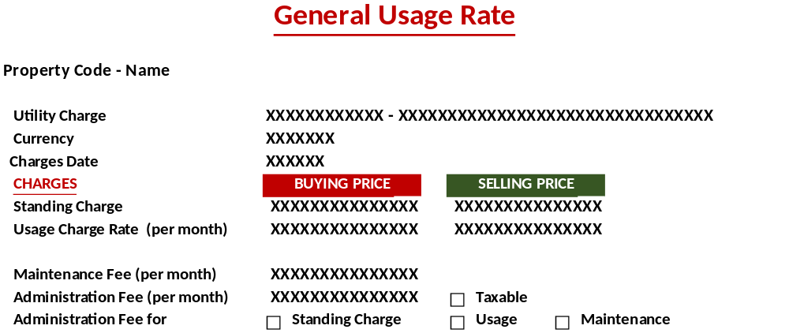
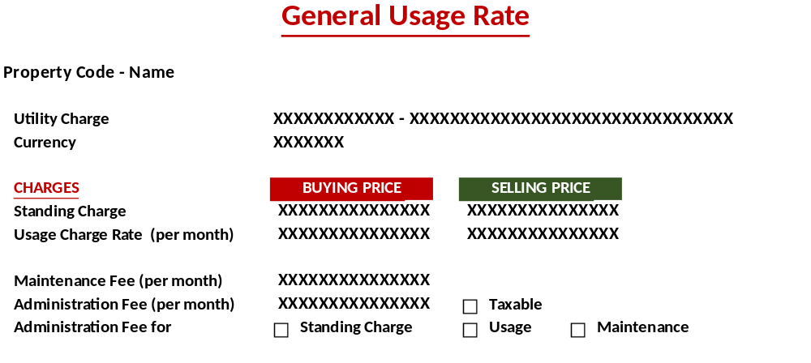

DISPLAY PROCESS
Test
Load Charges Rate Detail [CHARGES_RATE_DETAIL]

EXEC RSP_PM_GET_CHARGES_UTILITY_RATE_GU @CCOMPANY_ID, @CPROPERTY_ID, @CCHARGE_TYPE_ID, @CCHARGES_ID, @CUSER_LOGIN_ID

- Display data [CHARGES_RATE_DETAIL]:
  - "Utility Charge Id"
    - Textbox
    - Display = CCHARGES_ID, CCHARGES_NAME

  - "Currency Code"
    - Textbox
    - Display = CCURRENCY_CODE
[CR10]
  - "Date"
    - Textbox
    - Display = CCHARGES_DATE
[CR10/]

CHARGES
  - "Standing Charge"
    - Buying Price
      - Textbox
      - Display = NBUY_STANDING_CHARGE

    - Selling Price
      - Textbox
      - Display = NSTANDING_CHARGE

  - "Usage Charge Rate*"
    - Buying Price
      - Textbox
      - Display = NBUY_USAGE_CHARGE_RATE

    - Selling Price
      - Textbox
      - Display = NUSAGE_CHARGE_RATE

  - "Maintenance Fee (per month)"
    - Textbox
    - Display = NMAINTENANCE_FEE

  - "Administration Fee (per month)"
    - Radio Button
    - Field = CADMIN_FEE
    - Display = CADMIN_FEE_DESCR
    - IF 02: Percentage, enable:
      - "Administration Fee percentage"
        - Display = NADMIN_FEE_PCT
    - IF 01: Fixed Amount, enable:
      - "Administration Fee Fix Amount"
        - Display = NADMIN_FEE_AMT
  - "Taxable"
    - Checkbox
    - Display = LADMIN_FEE_TAX
    - Value = [0] Unchecked / [1] Checked

  - "Administration Fee For"
    - "Standing Charges"
      - Checkbox
      - Display = LADMIN_FEE_SC
      - Value = [0] Unchecked / [1] Checked

    - "Usage"
      - Checkbox
      - Display = LADMIN_FEE_USAGE
      - Value = [0] Unchecked / [1] Checked

    - "Maintenance"
      - Checkbox
      - Display = LADMIN_FEE_MAINTENANCE
      - Value = [0] Unchecked / [1] Checked

OVERTIME

USER INTERFACE
[CR12]
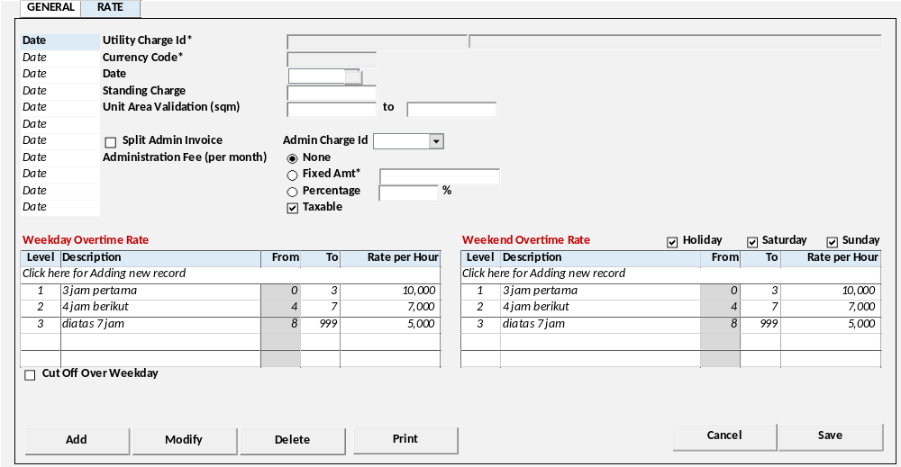
[CR10]
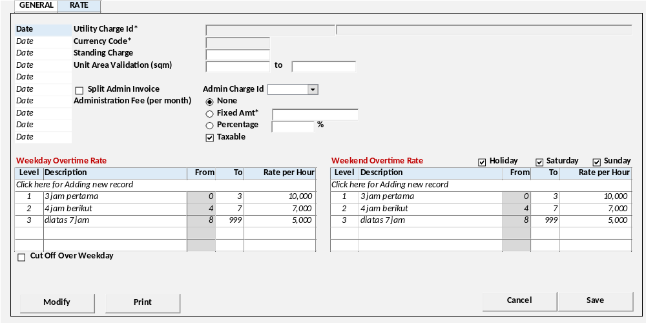
[CR09]
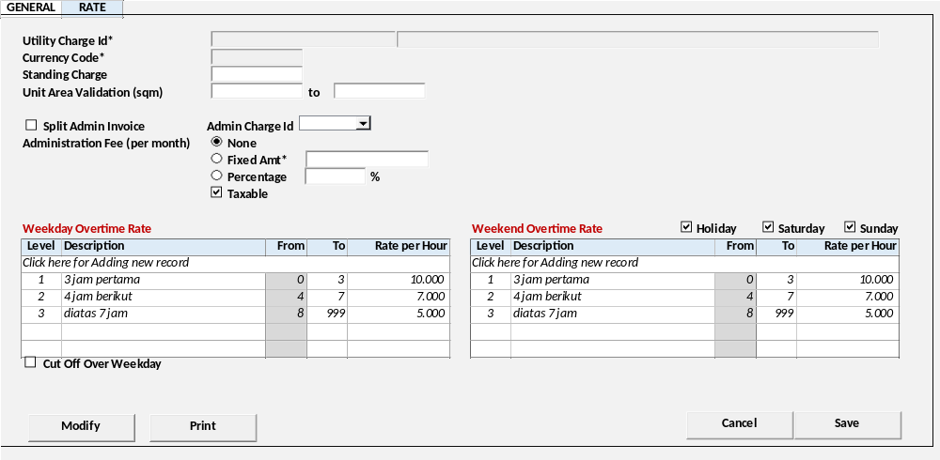

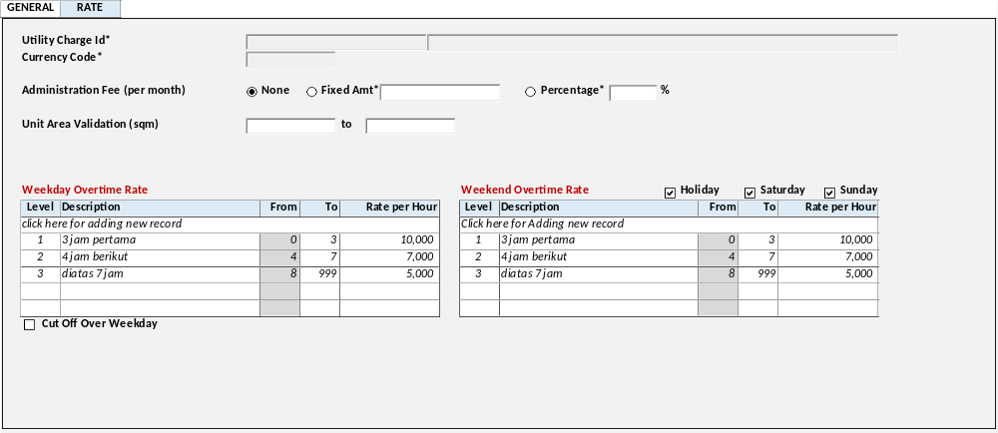

DISPLAY PROCESS
Test
[CR10]
Load Charges Rate Date [CHARGES_RATE_DATE]
EXEC RSP_PM_GET_CHARGES_UTILITY_RATE_OT_DATE @CCOMPANY_ID, @CPROPERTY_ID, @CCHARGE_TYPE_ID, @CCHARGES_ID, @CUSER_LOGIN_ID
  - "Date"
    - Textbox
    - Display = CCHARGES_DATE
[CR10/]

Load Charges Rate Detail [CHARGES_RATE_DETAIL]

EXEC RSP_PM_GET_CHARGES_UTILITY_RATE_OT @CCOMPANY_ID, @CPROPERTY_ID, @CCHARGE_TYPE_ID, @CCHARGES_ID, [CR10] @CCHARGES_DATE, @CUSER_LOGIN_ID

- Display data [CHARGES_RATE_DETAIL]:
  - "Utility Charge Id"
    - Textbox
    - Display = CCHARGES_ID, CCHARGES_NAME
    - VARCHAR(20), NVARCHAR(100)
    - Disabled

  - "Currency Code"
    - Textbox Lookup
    - Display = CCURENCY_CODE
    - VARCHAR(3)
[CR13]
    - Value = Lookup GSL00300 – CURRENCY LOOKUP
With Parameter:
Login Company Id
Login User Id

[CR10]
  - "Date"
    - Datetime Picker
    - Display = CCHARGES_DATE
    - Default Value = Today Date
[CR10/]

  - [CR09] "Split Admin Invoice" Flag
    - Checkbox
    - Display = LSPLIT_ADMIN
    - Value = [0] Unchecked / [1] Checked
    - IF Checked, enable
      - "Admin Charge Id"
        - Combobox
        - Field = CADMIN_CHARGE_ID
        - Value =
RSP_PM_GET_CHARGES_UTILITY_LIST @CCOMPANY_ID, @CPROPERTY_ID, ‘09’, @CUSER_LOGIN_ID

  - "Administration Fee (per month)"
    - Radio Button
    - Display = CADMIN_FEE
    - Value =
SELECT CCODE, CDESCRIPTION FROM RFT_GET_GSB_CODE_INFO
('BIMASAKTI', [Login Company Id], '_ADMIN_FEE_TYPE', '', [Login Language Id])
    - [CR08] Default = '00' None
    - IF 02: Percentage, enable:
      - "Administration Fee percentage"
        - Display = NADMIN_FEE_PCT
        - Numeric Input Only
        - Max = 100
        - Min = 0
    - IF 01: Fixed Amount, enable:
      - "Administration Fee Fix Amount"
        - Display = NADMIN_FEE_AMT
        - Numeric Input Only

  - "Unit Area Validation (sqm)"
    - From
      - Textbox
      - Display = NUNIT_AREA_VALID_FROM
      - Numeric Input Only
    - To
      - Textbox
      - Display = NUNIT_AREA_VALID_TO
      - Numeric Input Only

  - "Cut Off Over Weekday"
    - Checkbox
    - Display = LCUT_OFF_WEEKDAY
    - Value = [0] Unchecked / [1] Checked
    - Default = [0] Unchecked

Weekday Overtime Rate
EXEC RSP_PM_GET_CHARGES_UTILITY_RATE_OT_LIST @CCOMPANY_ID, @CPROPERTY_ID, @CCHARGE_TYPE_ID, @CCHARGES_ID, ‘WD’, @CUSER_LOGIN_ID

Display = CDAY_TYPE
Value = [WD] Weekday
  - "Level"
    - Textbox
    - Display = ILEVEL
    - Numeric Input Only
  - "Description"
    - Textbox
    - Display = CLEVEL_DESC
    - NVARCHAR(255)
  - "From"
    - Textbox
    - Display = IHOURS_FROM
    - Numeric Input Only
  - "To"
    - Textbox
    - Display = IHOURS_TO
    - Numeric Input Only
  - "Rate per Hour"
    - Textbox
    - Display = NRATE_HOUR
    - Numeric Input Only

Weekend Overtime Rate
EXEC RSP_PM_GET_CHARGES_UTILITY_RATE_OT_LIST @CCOMPANY_ID, @CPROPERTY_ID, @CCHARGE_TYPE_ID, @CCHARGES_ID, ‘WK’, @CUSER_LOGIN_ID

Display = CDAY_TYPE
Value = [WE] Weekend

  - "Level"
    - Textbox
    - Display = ILEVEL
    - Numeric Input Only
  - "Description"
    - Textbox
    - Display = CLEVEL_DESC
    - NVARCHAR(255)
  - "From"
    - Textbox
    - Display = IHOURS_FROM
    - Numeric Input Only
  - "To"
    - Textbox
    - Display = IHOURS_TO
    - Numeric Input Only
  - "Rate per Hour"
    - Textbox
    - Display = NRATE_HOUR
    - Numeric Input Only

- Proses
        - "Add New" Go to ADD NEW PROCESS
        - "Edit" Go to EDIT PROCESS
        - "Delete" Go to DELETE PROCESS

ADD PROCESS
[CR12] | Test
- Set VAR_SAVE_MODE = ADD
- Enabled fields: All Field
- Disabled fields: "Charges Id",[CR13] "Currency"
- Set focus to column: "Charges Date"

- Proses
        - “Save” Go to SAVE & VALIDATION PROCESS
        - “Cancel” Go to DISPLAY PROCESS

EDIT PROCESS
[CR01] | Test
- Set VAR_SAVE_MODE = EDIT
- Enabled fields: All Field
- Disabled fields: "Charges Id",[CR13] "Currency" , [CR10] "Charges Date"
- Set focus to column: "Administration Fee (per month)"

- Proses
        - “Save” Go to SAVE & VALIDATION PROCESS
        - “Cancel” Go to DISPLAY PROCESS

DELETE PROCESS
[CR12] | Test
- Delete Utility Rate
  - Overtime
IF "Charges Type" = 08 Overtime
CREATE TABLE #CRATE_OT_LIST (CCOMPANY_ID VARCHAR(8)
, CPROPERTY_ID VARCHAR(20)
, CCHARGES_TYPE VARCHAR(2)
, CCHARGES_ID VARCHAR(20)
, CDAY_TYPE VARCHAR(2)
, ILEVEL INT
, CLEVEL_DESC NVARCHAR(255)
, IHOURS_FROM INT
, IHOURS_TO INT
, NRATE_HOUR NUMERIC(18,2)
)
INSERT INTO #CRATE_OT_LIST

VALUES
[Login Company Id]
,[Selected Property Id]
, "Charges Type"
, "Charges Id*" Code
, "Charges Date"
, Day Type [WD] Weekday / [WK] Weekend
, "Level"
, "Description"
, "From"
, "To"
, "Rate per Hour"

EXEC RSP_PM_MAINTAIN_RATE_OT
"Login Company Id"
, "Property Id"
, "Charges Type"
, "Charges Id*" Code
, "Administration Fee (per month)"
, "Administration Fee percentage"
, "Administration Fee Fix Amount"
, "Unit Area Validation (sqm)" From
, "Unit Area Validation (sqm)" To
, "Split Admin”
, "Admin Charge Id”

, CACTION [DELETE]
, Login User Id

- Go to DISPLAY PROCESS

SAVE & VALIDATION PROCESS
[CR01] | Test
- Save Utility Rate
  - Overtime
IF "Charges Type" = 08 Overtime
[CR03]
DECLARE @CRATE_OT_LIST AS RDT_COMMON_OBJECT

INSERT INTO @CRATE_OT_LIST (
COBJECT_ID, COBJECT_DESC, CATTRIBUTE01, CATTRIBUTE02, CATTRIBUTE03, CATTRIBUTE04, CATTRIBUTE05, CATTRIBUTE06, CATTRIBUTE07, CATTRIBUTE08)
CREATE TABLE #CRATE_OT_LIST (CCOMPANY_ID VARCHAR(8)
, CPROPERTY_ID VARCHAR(20)
, CCHARGES_TYPE VARCHAR(2)
, CCHARGES_ID VARCHAR(20)
, CDAY_TYPE VARCHAR(2)
, ILEVEL INT
, CLEVEL_DESC NVARCHAR(255)
, IHOURS_FROM INT
, IHOURS_TO INT
, NRATE_HOUR NUMERIC(18,2)
)
INSERT INTO #CRATE_OT_LIST
[CR03]

VALUES
[Login Company Id]
,[Selected Property Id]
, "Charges Type"
, "Charges Id*" Code
[CR10], "Charges Date"
, Day Type [WD] Weekday / [WK] Weekend
, "Level"
, "Description"
, "From"
, "To"
, "Rate per Hour"

EXEC RSP_PM_MAINTAIN_RATE_OT
"Login Company Id"
, "Property Id"
, "Charges Type"
, "Charges Id*" Code
, "Administration Fee (per month)"
, "Administration Fee percentage"
, "Administration Fee Fix Amount"
, "Unit Area Validation (sqm)" From
, "Unit Area Validation (sqm)" To
, [CR09] "Split Admin”
, [CR09] "Admin Charge Id”

, CACTION [ADD / EDIT]
, Login User Id
[CR03], @CRATE_OT_LIST
, [CR13] Currency Code

- Go to DISPLAY PROCESS

PRINT PROCESS

USER INTERFACE
[CR10]
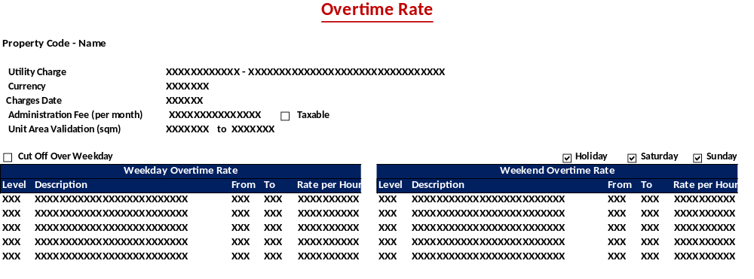
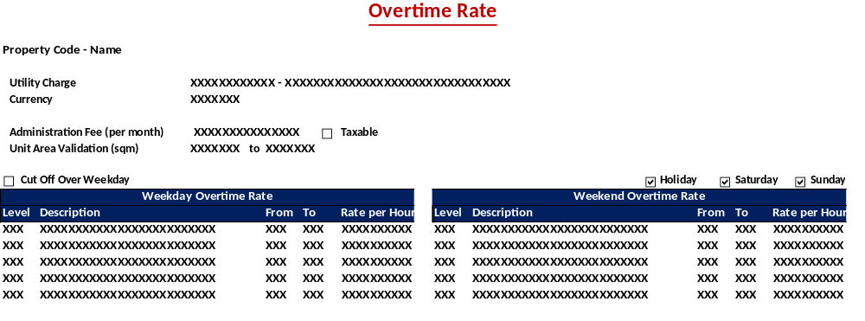

DISPLAY PROCESS
Test
Load Charges Rate Detail [CHARGES_RATE_DETAIL]

EXEC RSP_PM_GET_CHARGES_UTILITY_RATE_OT @CCOMPANY_ID, @CPROPERTY_ID, @CCHARGE_TYPE_ID, @CCHARGES_ID, @CUSER_LOGIN_ID

- Display data [CHARGES_RATE_DETAIL]:
  - "Utility Charge Id"
    - Textbox
    - Display = CCHARGES_ID, CCHARGES_NAME

  - "Currency Code"
    - Textbox
    - Display = CCURRENCY_CODE
[CR10]
  - "Date"
    - Textbox
    - Display = CCHARGES_DATE
[CR10/]

  - "Administration Fee (per month)"
    - Radio Button
    - Field = CADMIN_FEE
    - Display = CADMIN_FEE_DESCR
    - IF 02: Percentage, enable:
      - "Administration Fee percentage"
        - Display = NADMIN_FEE_PCT
    - IF 01: Fixed Amount, enable:
      - "Administration Fee Fix Amount"
        - Display = NADMIN_FEE_AMT

  - "Unit Area Validation (sqm)"
    - From
      - Textbox
      - Display = NUNIT_AREA_VALID_FROM
    - To
      - Textbox
      - Display = NUNIT_AREA_VALID_TO

  - "Cut Off Over Weekday"
    - Checkbox
    - Display = LCUT_OFF_WEEKDAY
    - Value = [0] Unchecked / [1] Checked

Weekday Overtime Rate
EXEC RSP_PM_GET_CHARGES_UTILITY_RATE_OT_LIST @CCOMPANY_ID, @CPROPERTY_ID, @CCHARGE_TYPE_ID, @CCHARGES_ID, ‘WD’, @CUSER_LOGIN_ID

  - "Level"
    - Textbox
    - Display = ILEVEL
  - "Description"
    - Textbox
    - Display = CLEVEL_DESC
  - "From"
    - Textbox
    - Display = IHOURS_FROM
  - "To"
    - Textbox
    - Display = IHOURS_TO
  - "Rate per Hour"
    - Textbox
    - Display = NRATE_HOUR

Weekend Overtime Rate
EXEC RSP_PM_GET_CHARGES_UTILITY_RATE_OT_LIST @CCOMPANY_ID, @CPROPERTY_ID, @CCHARGE_TYPE_ID, @CCHARGES_ID, ‘WK’, @CUSER_LOGIN_ID

  - "Level"
    - Textbox
    - Display = ILEVEL
  - "Description"
    - Textbox
    - Display = CLEVEL_DESC
  - "From"
    - Textbox
    - Display = IHOURS_FROM
  - "To"
    - Textbox
    - Display = IHOURS_TO
  - "Rate per Hour"
    - Textbox
    - Display = NRATE_HOUR

ERROR CODE / WARNING MESSAGE DEFINITION
Error Code / Warning Message | Error Message

CR LIST
CR | Description | Notes
CR01  15 June 2023 | - Mengubah process saving General dan Rate (dipisah save masing2 tab)
CR02  26 June 2023 | - Menambahkan informasi created date, created by
CR03  RE, 18 August 2023 | - Mengubah penggunaan RDT_COMMON_OBJECT
CR04  RE, 22 August 2023 | Tab General:  - Mengubah letak enable Accrual Journal  - Menambah Accrual Method
CR05  RE. 16 Okt 2023 | - Tidak ada opsi status draft, status jadi flag active.  - Mengubah default flag Active = true dan saat save “add” baca Activity Approval
CR06  RE, 16 Nove 2023 | - Mengubah ITAX_EXEMPTION_PCT menjadi NTAX_EXEMPTION_PCT, bisa input decimal.
CR07  RE, 29 Des 2023 | - Menambahkan warning message untuk Utility dengan detail Rate, saat delete akan menghapus rate yg sudah ada.
CR08  RE, 10 Jan 2024 | - Menambahkan default value untuk radio button, dan jika single rate, maka detail nya disabled
CR09  IB, 03 Apr 2024 | - Menambahkan Split Admin Invoice dan Admin Charge Id
CR10  RE, 15 August 2024 | - Menambahkan history pada rate
CR11  RE, 21 August 2024 | - Tab General – flag enable accrual di hide, “Accrual Method” mandatory IF Utility Journal Group.LACRRUAL = true
CR12  RE, 23 September 2024 | - Menambahkan button add/ delete pada rate
CR13  RE, 1 Okt 2024 | - Menambahkan lookup currency
CR14,CH  29 Jan 2025 | - Tambah Tax Charges Id untuk coretax

